YoungPeople@Work
Reg. nr: 2012/210099/08 NPC

ANNUAL REPORT
Period: 1 March 2014 – 28 February 2015

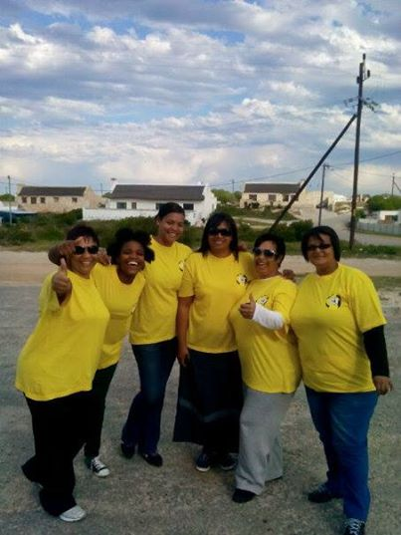

Prepared by: Frank Julie

Contact us here:
Cnr. Lavis Drive and Helderberg Road
Bishop Lavis
7490
Tel: 021 823 7837
Fax: (021) 911 5444
Cell: 073 820 1534
E-mail: youngpeople.za@gmail.com
Website: www.youngpeopleatwork.weebly.com
This is the second annual report of YoungPeople@Work (YP@W) covering the period 1 March 2014 – 28 February 2015. This report will cover the following:
- Brief background to YP@W
- Update on our projects
  - Community Information Sessions/Youth Empowerment Weeks
  - Online Job Search Training
  - Computer Training Academy
    - Community Investment Programme
  - Life Skills Workshops
  - Job Placement and Tracking
  - Rural Outreach Project
- Media and Marketing
- Networking
- Fund Development
- Finance
- Office Administration
- Other developments
  - New offices and training centre
  - Board Development and Governance
  - Youth Cooperatives
  - What some beneficiaries had to say
  - Risk factors – staff and volunteer retention/funding/succession planning
  - Expression of gratitude

Brief background to YP@W
YoungPeople@Work is the brainchild of Frank Julie and Marileze Johannes. Both were part of the first generation members of the Resource Action Group (RAG), a non-profit youth development agency established in 1992. Frank Julie was the founder and executive director of RAG for 10 years before departing in 2003 to pursue a career as fulltime development consultant. In 2007 RAG collapsed due to a lack of funding. In 2009/2010 the first generation of RAG volunteers and staff regrouped and decided to re-launch the organisation under a new name – YoungPeople@Work. YP@W was launched in March 2012. Many of the professional volunteers supporting YP@W today have their roots in RAG where they were trained and graduated and now give back to the community.

Since March 2012 until June 2013 the organisations was driven solely by unpaid volunteers. Bishop Lavis library became the initial base from which we started to operate. Various life skills workshops were offered followed with computer literacy training. A core group of volunteers were recruited and trained as computer facilitators. Adonia Life in Bishop Lavis provided free training and office space from June 2013 as YP@W gradually grew and became consolidated. All the volunteers who joined in 2012 were able to access jobs outside YP@W except for one, Shirley De Jongh, who became Operations Manager.

Small scale funding was accessed in 2013 and 2014 that allowed us to pay small stipends to the newly recruited volunteers to cover transport and food expenses. Our computer training academy was launched in July 2013 allowing us to generate income to cover some overheads. Our volunteers also engaged in various fundraising events such as rummage sales, karaoke evenings, membership fees and individual donations via Facebook to generate income. All this helped to stabilise the organisation and laid the foundation for the rapid growth we are experiencing today.

Update on our projects:
Community Information Sessions and Youth Empowerment Weeks
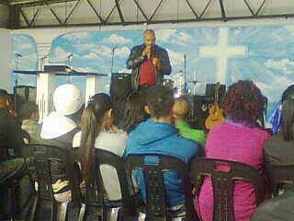
A 3-day Youth Empowerment Week was hosted at Ravensmead High School in May 2014 in collaboration with RUCdi, a local development agency. It was attended by over 40 unemployed youth. Partners who participated were the Department of Labour, Dreamworker, University of the Western Cape, Career Planet, Job Start and Buzz Idea.

Due to a lack of funding and internal pressures for volunteer development and staff training we decided to downscale our 3-day Youth Empowerment Weeks to 1-day Youth Information Days. We hosted these in Atlantis (attended by 25 people), Valhalla Park (attended by 15 people) and at Arcadia High School attended by 44 martriculants. An outreach to Mamre was postponed due to the weather. The strength of this programme is its ability to reach many unemployed youth in a short space of time with minimal planning and resources.

Recommendations:
During our annual assessment we decided to become more proactive with this programme and instead of waiting for requests for information rather approach groups to make presentations about YP@W. More volunteers will therefore be trained to present information sessions. Our target for 2015 will be 5 high school and 5 community groups.

Online Job Search Training
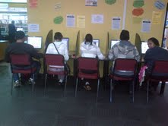

This programme was rolled out at Bishop Lavis, Bonteheuwel, Lwandle, Ravensmead, Valhalla Park, Adriaanse and Kensington libraries. The latter was initiated and managed by Achfa Projects based in Kensington with the support of YP@W volunteers. More than 500 unemployed youth were trained at the various libraries. Training was over 4 days with 2 hours per session covering Intro to computers, basic word processing, how to complete a CV and exposure to various websites to find jobs. Participants were also assisted to open their own Facebook pages and email accounts. The purpose of the latter is to facilitate our follow up strategy and staying in contact with our beneficiaries. A number of people accessed jobs during this training whereas others were referred to study and training opportunities. Some participants also joined the YP@W intensive computer course. The programme is free and allows easy access to unemployed youth to training and referrals. HCI Foundation funded this programme.

Some of our challenges include cable theft at the libraries which disrupts the flow of the training. Bishop Lavis and now recently Adriaanse library have been particularly vulnerable. Cooperation by library staff is also vital for the success of this programme, especially in terms of creating awareness amongst library patrons. During the latter part of 2014 (from October – November) we experienced a small decline in attendance at Bonteheuwel and Bishop Lavis libraries. This was ascribed to a lack of marketing and awareness.

Recommendations:
We decided to increase the contact time with an extra 4 sessions over 2 hours per session. The training will therefore be over 8 sessions over 2 hours each. This will allow us more time with participants and increase our ability to support them with CVs, referrals and job placements. It was felt that the library and not our training centre should be the first point of intervention for job placements. Participants at Lwandle library will also receive a special life skills week since they have difficulty travelling to our centre in Bishop Lavis.

Computer Training Academy
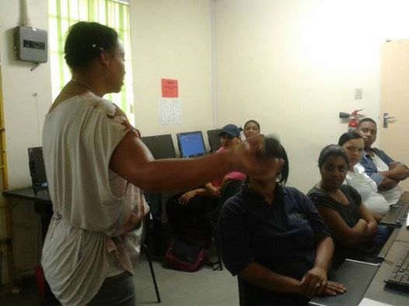

A total of 108 students were trained of whom 85 completed. This year we were able to attract more people due to our increased marketing with pamphlets distributed door to door. Many participants were referred by previous ones. Marketing via Facebook and through the library online job search training also played a role. More computer students attended our life skills course. Our computer fees came in well compared to last year. Through funding from Grandwest CSI we were able to upgrade our computer equipment. This resulted in fewer hard and software problems. More computer facilitators were also trained and current ones retrained. There was also an increase in the number of participants accessing employment after their training.

We are still in the process of working on our advanced training module to be launched. Training was provided by Yolanda Van der Westhuizen and Estelle Hendricks. We also decided to restructure the course and offer it over 5 weeks with training over 4 days per week instead of over 3 months with 2 days per week training. A life skills week will be added during the computer course making the course duration 6 weeks. A trainer council will also be evaluating our course manuals and make the relevant changes. During September we were supported by Nan Van der Storm from Holland with the training of our computer facilitators.

Some of our challenges are a lack of Internet access and technical support when computer systems experience problems. This will be attended to in 2015. Outstanding computer fees will also be addressed by developing a more efficient system of fee collection.

Community Investment Programme
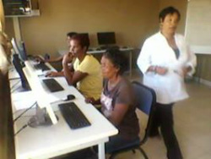

This programme is aimed at empowering community members active within with community organisations as volunteers and who are ploughing back within their communities with computer skills free of charge. This year we provided training to volunteers from the Young Urban Women, Masakhane, Counselling and Social Development Centre, 8 ste Laan in Valhalla Park and Adonai Life. Some of the volunteers continued to enrol for our intensive paid computer course and also joined our life skills course.

During 2015 we plan to formalise the system more and identify beneficiary groups in advance. We plan to run 7-10 CIP sessions and will identify groups to be invited.

Life Skills Workshops
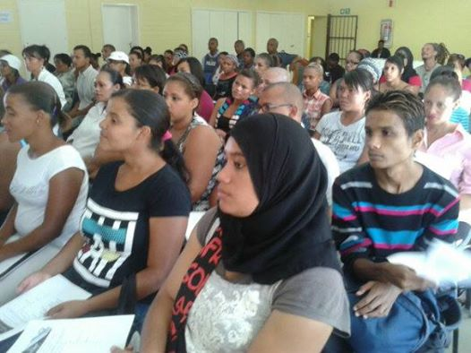

8 life skills workshops were offered this year. This most popular workshops were basic office and bookkeeping skills. An average of 250 enquiries are usually received with an attendance of approximately 80 people per session. Other workshops include personal development and leadership, professional networking, money management, customer relations and project/event management. An average of 30-40 participants usually attend. 3 life skills courses were offered this year. The organisation of these workshops was supported by a strong administration. To recover and minimise costs for this non-funded programme we urged participants to bring donations of tea/coffee, sugar and milk. This was well received but room for improvement still exists. The sale of life skills manuals also added to our cost recovery.

Recommendations for 2015 will be to train more volunteers as life skills facilitators. Volunteers have already identified workshops they want to learn how to facilitate and their training have already commenced. In future the job seeking and professional networking workshop will be collapsed into one.

Job Placements and Tracking
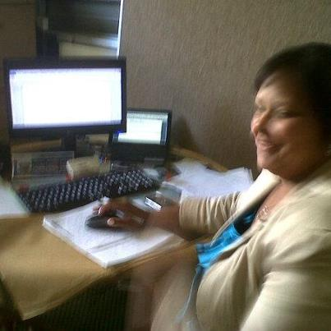

We were able to place more participants into jobs than last year. Tracking was done in June and November.
We plan to beef up this department and become more focused. Our Operations Manager was not able to provide her undivided attention to this area of our work due to computer training responsibilities. This was addressed by training extra computer facilitators which will allow her to reduce her training responsibilities.
We have received numerous requests from various partners for job referrals and will be consolidating these during 2015. A volunteer will also be recruited to assist with capturing of relevant information to streamline our placement and referral process. Our databases in our CV Bank and SMS Alert Service will also be overhauled. Partnerships with those offering matric will also be identified due to the increasing number of enquiries we receive from participants who failed to complete high school.

Rural Outreach Programme
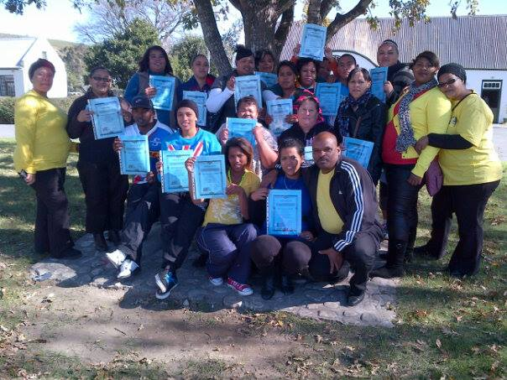

Rural outreach workshops were organised to rural areas such as Arniston, Suurbraak, Doring Bay and Darling. Our volunteers were exposed to the needs of other communities and were able to apply their skills. Unemployed youth were trained in basic computer literacy and life skills in Arniston and Suurbraak. The local Council of Stakeholders partnered with us to offer this training. IN Darling we partnered with the Swartland District Municipality. In Doring Bay/Ebenheaser training focused on leadership and organisational skills. Surplus People’s Project partnered with us in this community. Some of the youth trained are still active on our Facebook. We are planning to host a rural development programme, inviting at least two youth leaders from each community to join us for a 3 month course of intensive computer literacy, life skills, organisational development and media skills.
Media and Marketing
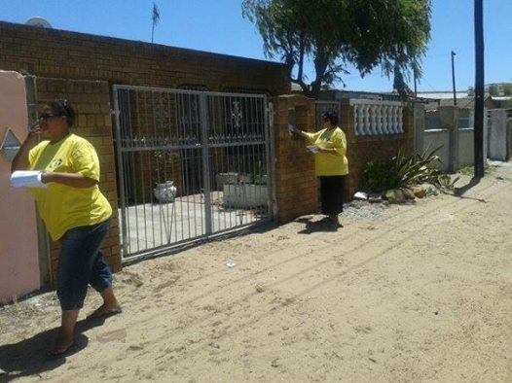

Our marketing campaign this year involved:
  - Newspapers (Tygerburger and People’s Post)
- Facebook with over 3500 people following us so far.
- Website – this is updated regularly. We plan to request that NPOs add our link to their websites.
- Door to door pamphleteering – this was done door to door in various communities such as Bishop Lavis, Valhalla Park, Bontehuewel, Ravensmead and Elsies River. 3 Malls were also targeted. We printed 10 000 pamphlets for distribution funded by Grandwest CSI.
- T-shirts – we printed 30 and plan to redesign it in 2015. One of our supporters, Debbie Willemse will design a sample and donate 10 T-shirts.
- Community radio – this was very positive especially Radio 786 who has been very generous in allowing us free airtime to market our programmes. Radio Smile has recently also come on board as well as Radio Cape Point.
- Murals were painted in various locations attracting attention to our work.
- Block emails – this was used to market our life skills workshops but were not too effective. Our online job search trainers have been requested to use block emails more often to stay in touch with their participants.
- SMS Alert System – this was not too effective due to technical problems experienced. We currently have over 1200 people on this database.
- Newsletter – we issued 4 electronic newsletters to 1900 subscribers. However the percentage (14%) of those opening up and reading the newsletters are not very encouraging. We plan to launch at least two printed versions of the electronic newsletters for distribution at our workshops and outreach work.
- We also plan to follow up a request made to Parow Mall to exhibit our services to unemployed youth. Exhibitions were hosted at Bishop Lavis and Adriaanse library.
- Cape Town TV also invited our projects director for a 30 minute panel interview on youth unemployment.
- A 7 minute video on the 2nd year of YP@W was completed by Estelle Hendricks, a board member.
- Two graduations were held in June and December with more than 100 guests and beneficiaries attending where we used the opportunities to showcase our work amongst unemployed youth. We plan to scale down to 1 graduation only in 2015.
- Whatsapp groups will be initiated by our office manager.
- Lwandle – the volunteer operating in this community will get newspapers and local community radio contacts.
- Word of mouth – this has been a strong way of referral, especially for our computer and online job search training.

Networking and building partnerships
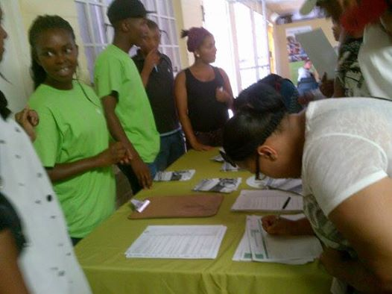
We partnered with the following organisations:

Organisation | Value received | Value added
Department of Labour | Provide free training in how to access public employment and worker rights | Exposure to unemployed youth
RLabs Social Media Academy | Provide free scholarships in social media courses to our volunteers and beneficiaries | Referrals
Career Planet | Awareness about free online job and training services | Referrals
Buzz Idea | Provide info about free entrepreneurship courses | Referrals
Community libraries | Free access to online computers and training space | Optimise use of libraries and enrolment for library cards
Counselling and  Social Development Centre | Access to discounted training, office space and kitchen facilities | Optimal use of facilities and financial donation
Council of Stakeholders | Access to rural youth for training | Free computer and life skills training
Harambee Job Placement | Information sharing about services to the unemployed | Referrals
Homemark | Information sharing about job vacancies and procedure to apply | Referrals
Dreamworker | Information sharing about services to the unemployed | Referrals
Jobstart | Information sharing about training in the tourism and hospitality sector | Referrals
Adonai Life | Free access to training and admin space (until October 2014) | Free computer and life skills training to members
University of the Western Cape | Information sharing about academic courses and Recognition of Prior Learning | Referrals
Surplus People’s Project | Free training in food security | Access to our volunteers
Achfa Projects | Opened free online job search training at the local library in Kensington | Provided free train the trainer training, life skills and support

We will become more proactive in 2015 to promote our work through our partners. This was identified as too lopsided since we are doing most of the promotional work and not vice-versa. Feedback is also very poor from partners as part of the follow up process.

Fundraising and development
Funding was received from the following donors:

Donor | Purpose | Amount (2014) | Amount (2013)
SPZA (Holland) | Towards operational costs and life skills workshops | R48 750 | R40 000
HCI Foundation | Towards our online job search training, admin | R65 000 | R50 000
Grandwest CSI | Towards marketing, equipment, manuals, admin | R105 000
Department of Social Development | Salaries and other operational costs | Application still at the assessment stage
Foschini CSI | Salaries and other operational costs | Turned down | Turned down
ACSA Foundation | Salaries and other operational costs | No response received. Donor officer resigned.
DG Murray Trust | Salaries and other operational costs | Application held back to address certain compliance issues
Absa Foundation | As above | No response
Dimension Data | 25 2nd hand computer | Still in process
South Africa Fund – Belgium | Request for operational expenses | Still in progress
Total amount of funding received |  | R278 750 | R90 000

Our own income generation was derived from:
- Computer income (our primary income derived from computer classes)
- Sales of flash disks
- Rummage sales
- Life skills manuals (workshops are free but a small fee is charged for the manual to recover costs)
- Membership fees (monthly donations by volunteers)
- Computer hardware sales
- Individual donations from professionals mainly via Facebook (2 appeals made in April and December)
- Material donations (10 free computers, 2 printers, stationery, office furniture, discounts, refreshments)
Total amount
Income stream | 2013 | 2014
Funded income | R97 000 | 278 750
Own income | R36 249 | 90 000
Total amount | 133 749 | 368 750

Breakdown of material donations/discounts received:
Donor | Donation/discount | Approximate value
J&B Associates Accounting | External audit | 12 000
Adonai Life | Free office and training space | R30 000
Freda Camphor | Free bookkeeping workshops (3) | R9000
Spark PR (USA) | 5 2nd hand computers with accessories | R10 000
Department of Social Development | 5 2nd hand computers | R5000
St Mary’s Home | 2nd hand clothing | R2000
Rainbow House | 2nd hand clothing and juice | R1000
Catholic Welfare and Development | 2nd hand furniture | R5000
Donations from participants during life skills workshops | Tea, coffee, sugar, milk | R3000
Total amount |  | R77 000

Focus for 2015
The Lotto and DG Murray Trust will be targeted as a matter of priority in 2015. Salaries is our biggest expense for whom we need at least 1 or 2 donors. Rental, printing, communications and transport are other important expenses. Computer fees remain our biggest income to be cultivated more in 2015. Outstanding computer fees amount to at least R10 000 and will be targeted. Computer and life skills manual fees will be slightly increased to enhance our income. More fundraising events will be planned. A clothing bank will be launched to ensure a regular income. Excess computer parts will be sold.

Finance and systems
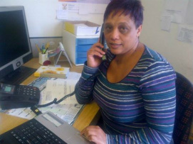

Audit report
We received our second successful external audit. The auditor was impressed with the progress made in record keeping of source documents and capturing of information. Financial reporting is done on a monthly basis and verbal feedback of account balances are provided on weekly basis at management planning meetings. Lizelle Kock will handle banking in 2015 and Shirley De Jongh will be responsible for banking preparation.

An electronic bookkeeping system will be investigated with one of our partners. Bookkeeping training was provided by Bronnie from Dreamworker, Freda Camphor and Cheryl-Lynn Freeman.

Application: Public Benefit Organisation/18A Status
This application was made to the SA Revenue Service (SARS) in May 2014. After numerous enquiries, delays and requests for additional information, we have received final confirmation, with a reference and case nr, that our application is in the final stages of being approved. This will enable us to acquire 18A Status allowing corporate donors to claim tax deductions on funding they invest in the organisation.

Office administration
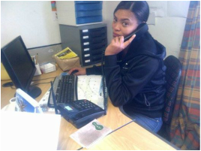
Since we moved to the Counselling and Development Centre we have access to more space and therefore privacy. Our telephone problems have also been solved with the acquisition of a new mobile phone from Neotel. Our filing system has improved with better recording of our client information. Most volunteers are also able to support with reception skills when needed. Our office manager attended a 2 day job shadowing at the Department of Labour in Bellville.

Issues to be addressed in 2015 are name tags for volunteers, monitoring of attendance register, developing a more central database of beneficiaries and getting our own access keys from the CSD Centre.
Board development and governance

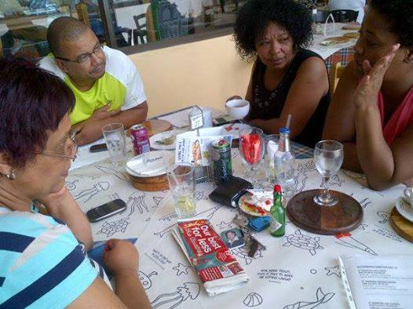
We held 3 board of directors meetings in 2014. Board members contributed towards the organisation in the following way:

Board member | Contribution
Marileze Johannes | Provided free training in office administration and assisted with setting up new computers and software installations.
Frank Julie | Free coaching, mentoring, training of trainers, management support, marketing, planning, volunteer evaluations, funding, transport and networking.
Ronald Wesso | Provided a free educational workshop on an assessment of the matric results and facilitated the rural outreach to Doring Bay/Ebenheaser.
Estelle Hendricks | Provided discounted training in Ms Excel, Ms PowerPoint and Ms Word and produced a free marketing video of YP@W
Shirley De Jongh | Provided free catering services at our graduations

Staff and volunteer changes

Member | Portfolio | Status
Frank Julie | Part-time volunteer Acting Director | Unchanged
Shirley De Jongh | Operations Manager and computer facilitator | Will focus more on job placements in 2015. Currently in training as office admin skills trainer
Jayson Magooda | Computer facilitator (evening classes) | Accessed new employment
Lorne Isaacs | Online job search trainer | Accessed new employment
Clothilda Petersen | Evening computer trainer and online job search trainer | Accessed new employment but still active as evening computer trainer
Doreen Cussendala | Online job search and CIP trainer | Unchanged; currently trained as a life skills trainer
Lizelle Kock | Online job search trainer | Will also offer afternoon computer classes in 2015 to relieve Shirley De Jongh. Currently in training as a customer care trainer
Mandilahke Songelwa | Online job search trainer | Currently in training as a computer and life skills trainer
Nasieba Adams | Online job search trainer and CIP assistant trainer | Will receive training in office admin as a trainer
Josephine Silbourne | Office manager and online job search trainer | Currently in training as an office admin skills trainer
Victoria Petersen | Volunteer | Employed full-time at Dreamworker but support YP@W during special events

Youth Cooperative Businesses
During our annual strategic assessment we decided to explore the establishment of youth cooperative businesses in 2015 as a part of a new strategy to assist unemployed youth to create employment and not just to access it. The acting director was tasked with the responsibility to investigate the viability of this project. Cooperatives to be explored are:
  - Car wash
  - Clothing bank
  - Cleaning
  - Laundry
  - Hairdressing

What some beneficiaries had to say:

Lorne Isaacs wrote:
"Hi all what a wonderful day this was, my first day at my new job and I wouldn't have been given this opportunity if it wasn't for Youngpeople@Work. It all started with a Personal Development Workshop where I discovered the true me and who I wanted to be then I developed my knowledge with all the workshops and computer classes that were available for free and I got a bursary to study @ Rlabs and received a UCT certificate and with my portfolio of evidence I applied and qualified for position and today I started my first day as a data capturer for the Foschini Group in the exports division. Thank you YP@W you have taught me that not even the sky is the limit we can dream and achieve beyond that Thank you!!!!!

Sheri-Lee Dreyer wrote:
"Good day Frank! I hope all is well.
I just want to thank you, Frank as well as your whole team from the bottom of my heart. I wanted to start my own NGO, however, through motivation and advise from you at the workshops I rather joined hands with existing organizations. So I am proud to say that today I got the news that I am officially employed at the Sports and Recreational Centre here in Belhar as team leader. Even though it is on a contractual basis I am grateful for the opportunity. And I thank you for all you do. So grateful for it. Thank you.”
Mariam Oliver (Director: Achfa Projects) wrote:
"As you can see, another group of unemployed youth graduated yesterday at the Kensington Library and Achfa Projects will continue with this successful model of Young People at Work. I do want to ask you if I could come more close to the other operations so that I can learn to be able to duplicate what is working in Bishop Lavis and other areas you have branched out to. I would like to request if it's possible for me and my volunteers (3) to attend your Friday staff and volunteer meetings so that we can learn how you do it."

Rural outreach:
Rene Pretorius from Suurbraak wrote:
"I want to thank YP@W for what they have done for us (Frank, Doreen and Poppie). I never had met so inspiring people that I can learn more from! You guys ROCK! Hope to see you very soon again!"

Celeste Hendricks from Suurbraak wrote:
"I am very impressed with YP@W. Our class was well presented. The two ladies Doreen and Poppie really had patience with us. And our class we had with Frank Julie was good and well presented. Thank you all and hope to have a next session! Love you all!"
Rovina Marthinus from Arniston wrote:
“I am very glad that I could attend this training to empower myself. The training was very good. The facilitators were very good. I could understand every word they taught.

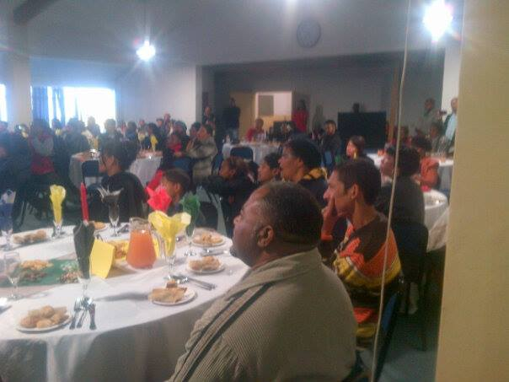
Graduation 14 June 2014

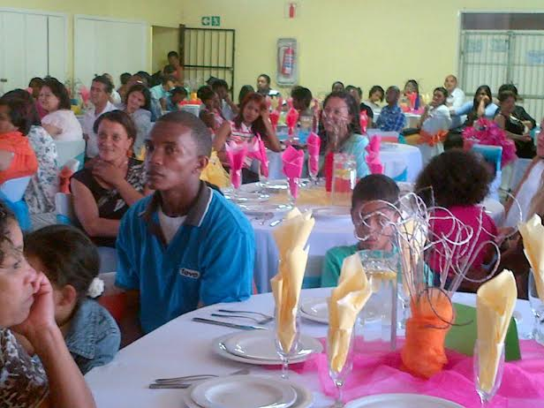
Graduation 13 December 2014

Risk factors for 2015:
- Staff/volunteer retention
This is our main risk to be managed in 2015. The lack of funding to pay market related salaries to our staff and volunteers may lead us to lose key staff and volunteers who have been trained for more than a year and sometimes two years. We have already lost all the trained volunteers from 2012 except one. Last year 3 trained volunteers accessed employment with one of them still facilitating evening computer classes on a contract basis. This matter is currently treated with utmost urgency. With the delays in funding, some of the volunteers are already exploring other more secure employment opportunities.

- Succession planning
The over-reliance on one person to facilitate the life skills course and manage the driving responsibilities must be addressed. Already a process of skills transfer was put in place to have more members train the life skills workshop and some volunteers have acquired their learner’s licences. A separate car for transport purposes is becoming urgent for the organisation.

Expression of gratitude
We sincerely thank all those who played a constructive part in the development and growth of YP@W during this reporting period. A special thanks to all our donors who believe in our work, our board, volunteers and beneficiaries who place their trust in our ability to serve them. We are humbled to have been able to touch the lives of so many unemployed youth in 2014.

Thank you

Frank Julie

