YoungPeople@Work
Reg. nr: 2012/210099/08 NPC

ANNUAL REPORT
Period: 1 December 2014 – 30 November 2015

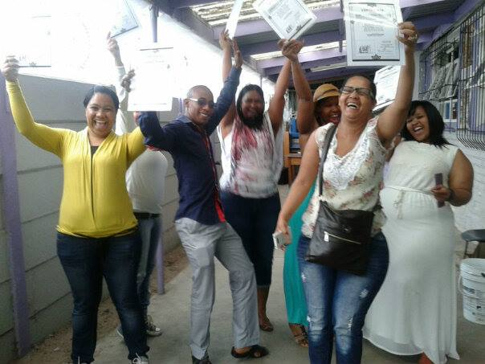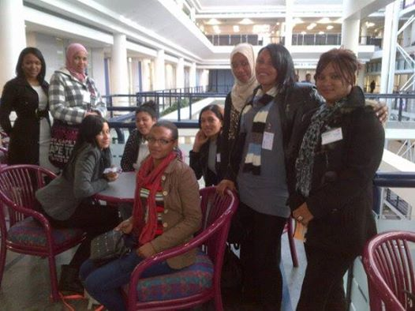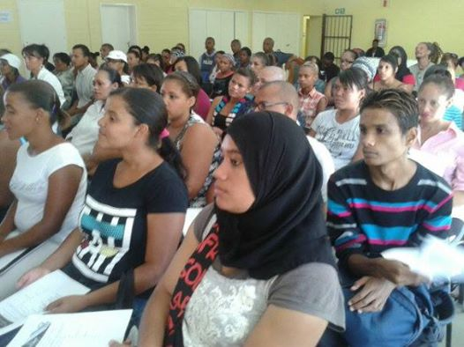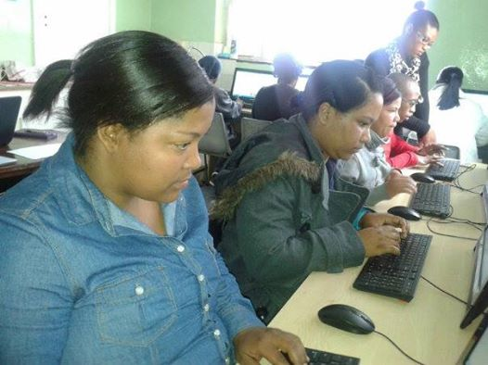

Prepared by: Frank Julie
Volunteer Projects Director

Contact us here:
Cnr of Lavis Drive and Helderberg Road
Bishop Lavis
7490
Tel: 021 823 7837
Fax: 021 911 5444
Cell: 073 820 1534
Email: youngpeople.za@gmail.com
Website: www.youngpeopleatwork.weebly.com

Introduction:
This is the third annual report of YoungPeople@Work (YP@W) covering the period 1 December 2014 – 30 November 2015. This report will cover the following:

- Update on our projects
  - Community Information Sessions/Youth Empowerment Weeks
  - Online Job Search Training
  - Computer Training Academy
    - Community Investment Programme
  - Life Skills Workshops
  - Job Placement and Tracking
  - Rural Outreach
- Media and Marketing
- Networking
- Fund Development
- Finance
- Office administration
- Board developments
- Other developments
  - Investment in other community organisations
    - TASP - Women’s Day event
    - Burnt down QQ crèche in Khayelitsha
    - Virtuous Women Pampering Group
  - Investment in volunteer development
  - Youth Cooperatives
  - What some beneficiaries had to say
  - Summary of overall investment in unemployed youth
  - Risk factors
  - Strategic focus areas for 2016
  - Expression of gratitude

Update on projects:

Community Information Sessions/Youth Empowerment Weeks
Only two Youth Empowerment Weeks were hosted namely in Khayelitsha (attended by about 60 participants) and Bellville South (also attended by about 60 participants). In Khayelitsha we partnered with Whizz Kids and in Bellville South with Rainbow Community Centre. Both events were over 3 days covering professional job seeking skills and basic office admin and money management skills. In Khayelitsha, Ronald Wesso from Surplus People’s Project (and YP@W board member) presented a special session on Rights of the employed in the workplace. In Bellville South we were joined by various partners such as RLabs Social Media Academy, local Community Police Forum, Department of Labour, SA Police (Bellville South Branch), local councillor, Dreamworker and the local Joint Operation Council, a network of community organisations in Bellville. We scaled down on this project due to funding constraints. Our focus for this year is to host more of these workshops over 2 days where some features of the online job search training can also be introduced such as Intro to computers, opening of email and Facebook accounts and CV completion. This will compensate for the libraries we are not able to access due to a lack of funds. Simultaneously it will assist in the marketing of our computer and life skills courses and streamline placements.

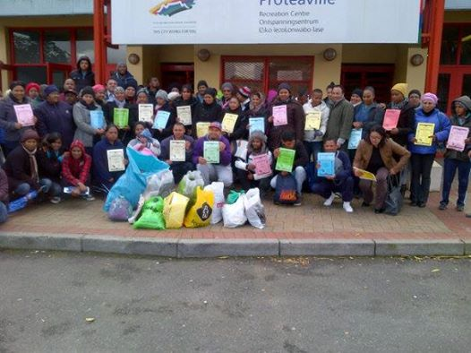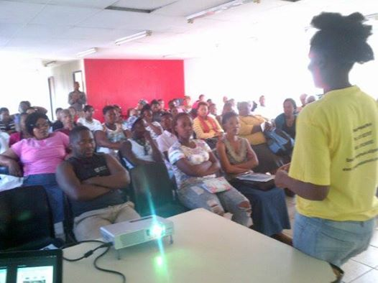

Online job search training
Numerous challenges were experienced with this training, especially in Bishop Lavis library where computers were stolen. We decided to use our own computers and converted our volunteer office into a training room with our Neotel wifi. Doreen Cussendala facilitated at least 3 groups. Adriaanse library was closed for renovations for 3 months and persistent Internet access problems at Lwandle library were experienced.

Adriaanse library continued with classes with Sisanda Gabada in charge of training after being mentored by Doreen Cussendala. Nasieba Adams was active at Kensington library and Mandilakhe Songelwa at Lwandle. Bonteheuwel library training stopped due to Internet problems.
We are exploring rolling out training at Delft library early next year in partnership with Lemosa, a local NPO. Meetings have already been held with the local library to finalise plans. Fewer participants were trained compared to last year due to two more days added to the training and disruptions at the libraries. We have evaluated this programme during our end of year assessment and have explored alternative ways to conduct this training in future. One idea is to use of Youth Empowerment Weeks as a training site.

Community libraries covered and tracking results:
The following libraries were covered during to this reporting period:

Tracking result | Kensington | Adriaanse | Lwandle | Bishop Lavis
Nr. trained | 84 | 34 | 60 | 49
Library cards applied for | 32 | 10 | 24 | 3
CVs used after training | 16 | 14 | 20 | 12
Accessed life skills | 0 | 10 | 6 | 13
Access intensive computer training | 0 | 0 | 7 | 1
Went for interviews | 11 | 3 | 2 | 2
Job placements | 3 | 4 | 0 | 2
Total number trained: 227 (510 trained in 2014)

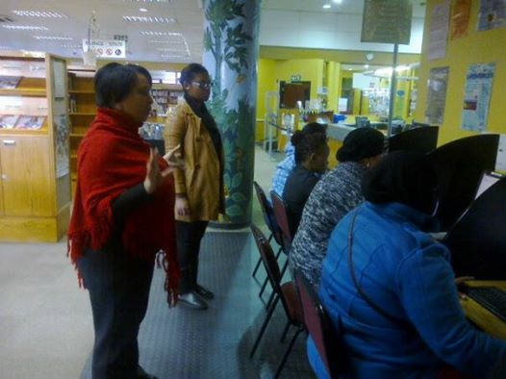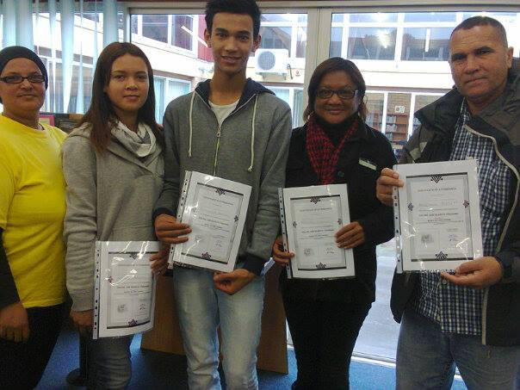

Computer training academy
The computer classes have run smoothly. The total number of students trained was:

Bishop Lavis training centre
1st semester | 2nd semester | 3rd semester | 4th semester | 5th semester
32 | 25 | 21 | 22 | 21
Total nr of students = 121
Bellville training centre
 |  | 3rd semester | 4th semester | 4th semester
 |  | 12 | 9 | 9
Total nr of students = 30
Overall total = 151 (108 trained in 2014)

The morning sessions are still the most popular with early afternoon classes filling up more slowly. Classes in Bishop Lavis fill up faster than in Bellville. Afternoon classes fill up slowly in Bellville. Lizelle Kock is currently training the morning and afternoon sessions in Lavis and Clothilda Petersen the evening slot. Shirley trains the morning and afternoon slots in Bellville. The Bellville training centre only started training in June.

Advanced classes
An intermediate and advance Ms Excel course was designed by Shirley and will be offered this year. We advertised the course last year but actual registrations were weak despite numerous enquiries. An advanced Ms Word will also be designed. We are hoping that this will create another income stream and strengthen our own income potential.
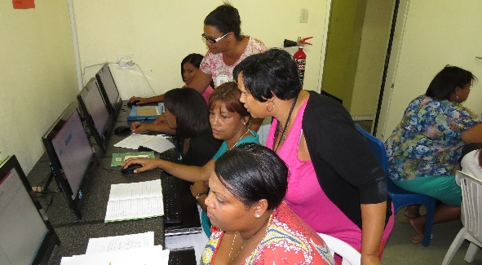

Community Investment Programme
Doreen Cussendala has been facilitating training for various partners which included members from Tygerberg Association for Street People (TASP) in Bellville, Future Link (high school students from Lavis hosted by CSD), the Pampering Group of women and unemployed youth who graduated through our life skills programme. We have recently decided to charge a small fee of R75 per person where students can afford to pay, help us cover costs.
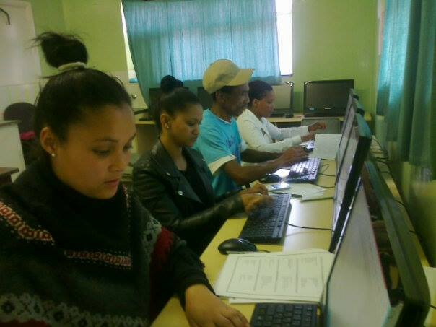 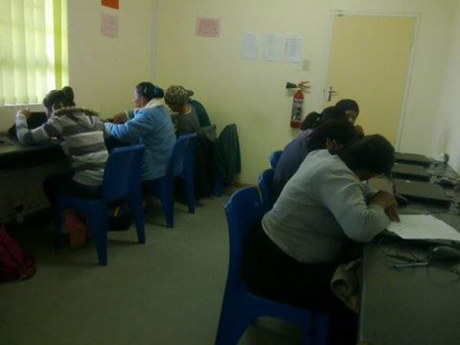

Life skills workshops
We hosted 3 life skills courses with a total of 500 participants of whom 381 was female and 119 male. The following partners participated namely, Harambee Youth Employment Accelerator, National Youth Development Agency (NYDA), Career Planet, Dreamworker, RLabs Social Media Academy, Homemark, Surplus People’s Project and Department of Labour.
Participants are now required to pay R5 per certificate (R10 for laminated certificates) to cover our cost of printing. We have also added two more workshops which include "How to grow a successful business" and "Effective stress management". We are planning to design a workshop on "Understanding body language" and "Effective coaching and mentoring". This will add more value to the course and it will be presented in 3 phases instead of the current two.
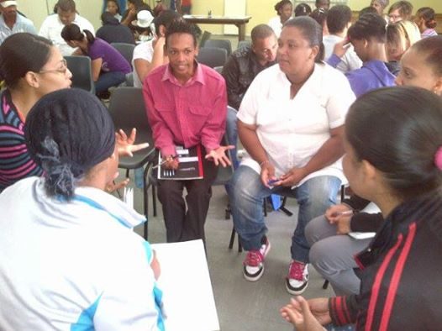

Job placement and tracking
Since we started to streamline this programme at the beginning of the year, we have produced much better results. Access to a hairdressing and safety and security learnerships were facilitated for a number of participants. Participants were placed at Sanlam Insurance in Bellville for a 3 month internship with some mixed results. Most participants had a very positive experience and a few felt disappointed by their advisors. Placements were also made at Homemark, Jazzart, Vision Homes and City of Cape Town. We are in the process of cultivating new placement partners, starting in our operational communities, especially amongst the local schools.

A summary of placements and income earned or savings made
Company/organisation | Nature of placements | Nr of placements
Mind Magic | Hairdressing learnership  100 referred, 21 placed, 14 remaining @ 1500 pm stipend | 14
Paper Mache (Bellville) | Training | 2 placed, 1 completed
Better Best | Safety and security learnership | 14 placed
I-Can (Elsies River) | Multi-media training  Film production, computer training, mobile apps,  project and events management, Audio visual  social media  Course value at an average of between R1700 and R4500 per course | 61
Primeserve SDF training | Skills Development Facilitator training @ 7500 per person | 7
Surplus People’s Project | Job shadowing in office admin and 1 year internship  @ 300 pm stipend (transport subsidy) and 2500 pm (internship x 10 months) | 4
Sanlam Insurance | 3 month internship @ average of R1000 pm | 14 placed
Vision Homes | Job placement  2 referred, 1 placed @ salary of 5000 pm | 1
Harambee | Job placements (no info available of income earned) | 38
Dreamworker | Job placements (no info available of income earned) | 22
City of Cape Town | Job placement (estimated salary @ 6000 pm) | 1
Homemark | Job placement (2 as store manager @ 8000 pm x 2 and 1 as sales representative @ 12 000 pm + 3500 pm transport allowance) | 3
Jazzart | Job placement (placed as intern over 3 months and permanently employed for 2016 @ 4500 pm) | 1
Home from Home | Job placement (permanent employment @ 4000 pm) | 1
Prestige Financial Services | 1 month internship (transport subsidy provided @ 300 pp) | 2
ARIBA (Canal Walk) | Job placement (permanently employed @ 4500 pm) | 1
Wheat Women’s Trust | 3 day per week admin internship @ R3000 pm | 1
Optica (Bellville) | Job placement (permanently employed @ 3000 pm) | 1
Nampak (Epping) | Job placement (permanently employed @ 6000 pm) | 1
Total referred and placed |  | 275

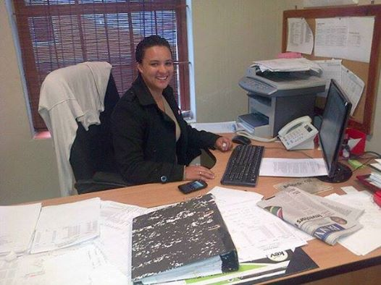

Rural outreach
We were invited by a group of professionals (some linked to the local Rotary Club) in Stanford to host a rural outreach over 3 days. About 35 participants attended. Doreen and Dineo assisted with CVs and admin. A very encouraging follow up report was received later tracking what happened to participants after the workshop. A follow up outreach is planned for March 2016 if funding applied for is made available.

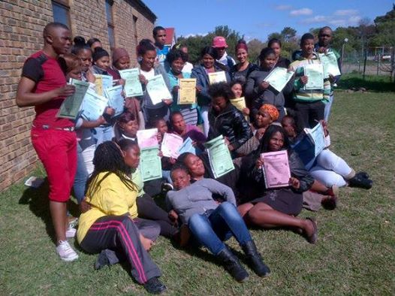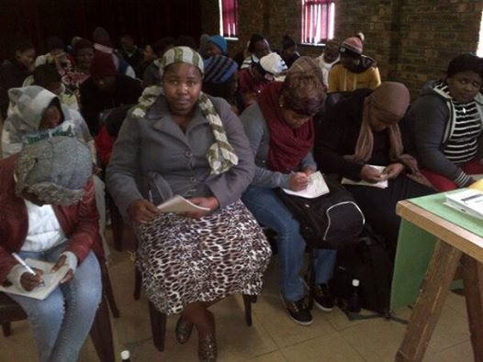

Media and Marketing
Marketing medium | Quantity and focus | Area covered
Pamphlets | 7000 colour pamphlets | Bishop Lavis, Bonteheuwel, Kensington, Delft, Belhar, Parow, Bellville, Elsies River, Montana, Vlahalla Park, Ravensmead
Posters | 100 colour posters focusing on computer training and life skills workshops | Local NPOs, surgeries, YP@W training centre, local businesses in Bellville
Murals | 4 murals focusing on computer classes and life skills workshops | Bishop Lavis (2)  Bellville (1)
Radio interviews | 3 interviews focusing on programmes for unemployed youth (Radio 786)  Interview on Radio Zibonele | Cape Peninsula
Cape Town TV | 1 interview on youth unemployment | National via DSTV
Banners | 2 completed focusing on YP@W programmes | Workshops and Bishop Lavis library exhibitions
Electronic newsletter | 4 editions focusing on youth issues, programme developments and YP@W success stories | 2000 subscribers nationally
Website | Continuous updating focusing on YP@W programmes | National and international
Facebook page | Daily updates on YP@W developments, success stories and job opportunities | 4482 followers nationally and internationally
Newspapers | Tygerburger – promoting computer and life skills workshops | 4 free articles and 3 paid adverts and 3 classified adverts covering areas such as Bishop Lavis, Bonteheuwel, Delft, Belhar, Elsies River, Valhalla Park with a circulation of 35 000 copies per newspaper
Block emails | Advertising our computer and life skills courses | Targeting mostly NPOs with youth volunteers
Whatsapp groups | Advertising our computer and life skills courses and advanced training | Targeting participants, ex-participants, walk-ins and youth empowerment week participants
Block sms’s | Advertising our computer and life skills courses and job opportunities | Targeting participants, ex-participants, walk-ins and youth empowerment week participants
Word of mouth | Advertising our computer and life skills courses and job opportunities | Continuous and our main marketing medium based on participant surveys in workshops and application forms

According to a survey conducted amongst our participants, the most popular mediums to find out about YP@W are:
- Word of mouth
- Newspaper (articles and adverts)
- Facebook
- Pamphlets
- Murals
- Radio
- Others

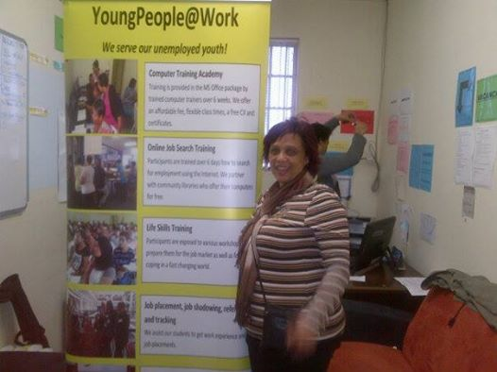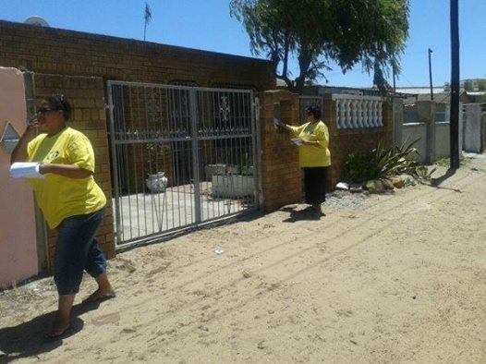

Networking
Our current network partners are:

Partner | Investment made
RLabs Social Media Academy | Free scholarships for social media training
Harambee Youth Employment Accelerator | Referrals for jobs at mostly retail companies
Department of Labour | Information about services and free labour advice
Dreamworker | Referrals for jobs
National Youth Development Agency | Information about youth services and funding for youth cooperatives
Emerging leaders | Leadership training
Tygerberg Association for Street People | Free training and office space
I-Can technology centre | Free bursaries for IT and social media raining
Virtuous Women Pampering Group | Free pampering sessions for female participants at selected workshops
Surplus People’s Project | Free facilitation of workshop on rights of the employed and internships
Community libraries | Free access to computers and WIFI for online job search training

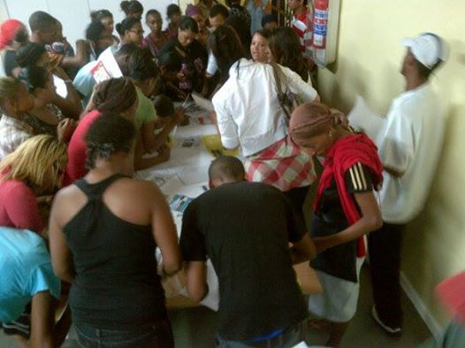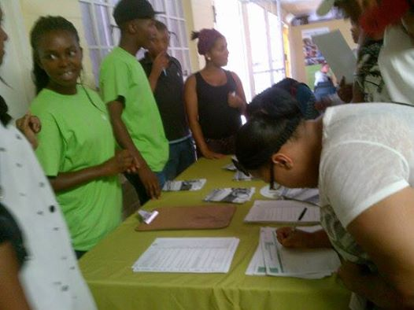

Fund Development
Donor | Amount requested | Status
SPZA | 60 000 | 30 000 granted (other R30 000 to be granted based on need) for life skills workshops, management coordination, online and computer trainer fees
HCI Foundation | 97 000 | 20 000 granted for online job search training
King Badouin Foundation | 100 000 | 99 692 (due to foreign exchange fluctuation) granted for overall programme and operational costs
Total amount |  | 149 692 (2014 - 278 750)
Funding applied for
Equal Opportunity Foundation | 50 000 | Feedback still awaited
National Lotteries Commission | 497 000 | Feedback still awaited
Australian Aid (Direct Assistance Programme) | 50 000 | Declined
New individual and repeat donors were also recruited such as Dawn Malatone-Lindsey (USA), Leonie Cloete (UAE), Luby Lui (UAE), Christo Van der Rheede (PTA) and Lana Maart (CT). Our office and training space were named after the first three for their consistent giving and support.

We have been able to exceed our target of R120 000 for 2015 own income. R90 000 was generated in 2014. This was due to a small increase in computer fees, cost recovery for certificates and CVs printed as well as small donations towards the CIP programme and sale of workshop manuals. Material donations from participants during workshops also helped to reduce costs. Repeat individual donors via Facebook also strengthened our own income base. Another factor was the streamlining of our collection of computer fees. The current collection rate is 98% compared to 75% last year. Outstanding fees for 2013 was also collected by means of small claims court notifications.

Own income generation
Income streams | Amount
Computer training fees, USB sales, computer manuals, rummage sales | 145 958
Workshop fees, manuals, CV typing, printing | 13 738
Individual donations (Facebook appeals) | 18 827
Volunteer contributions (for daily tea and coffees) | 100 pm x 12 = R1200
Subtotal | 179 723 (90 000 in 2014) (36 249 in 2013)
Material donations and estimated value
Material donations from workshop participants | 2000
Material donations from partners (Rainbow House, St Mary’s Home) | 3000
TASP – free rent in Bellville | 2000 p.m. x 6 = 12 000
J&B Associates and Accounting (auditors) | 13 000 (discount on audit report)
Subtotal | 30 000
Total amount | 209 723

We will explore more own income streams this year focusing on faxing, scanning, email/Internet, laminating and photocopying services. Our computer fees have already been increased with R100 even though it is still 4 times less than the market rate. Saturday computer classes will also be presented with new intermediate and advanced classes to be launched. Our target of own income will be set at R250 000. This is R160 000 more than in 2014.

Finance
We have produced our 3rd audit report. Our financial accountability systems are sound with rigorous check and balances. Our costs for volunteers have increased since we decided to increase the monthly stipends to retain them. This put pressure on our current finances since the expected funding did not materialise. Funding from HCI Foundation was much less than expected. We are still waiting for our PBO application from Sars. We had to fill in more forms and was recently informed to submit a form as proof address which CSD must co-sign. The forms have been completed and submitted. We are awaiting feedback from SARS. We also plan to contract the services of HGG financial advisors to assist with our monthly bookkeeping at a small negotiated fee of R500 per month. This will free our operations manager to focus more on placement and tracking.

Office administration
Our office has been running smoothly since we moved into our new training centre in September 2014. It has provided excellent support service to our computer and life skills training. We still lack some equipment such as a fax and copy machine. Access to WiFi also remains a challenge despite a contract with Neotel. The building we occupy is not so receptive. We are now considering an ADSL line from Telkom.
Board developments
Our board met three times this year. We still have the same board members as recorded last year. Victoria Petersen, an ex-volunteer now working for Dreamworker, has been appointed as a board member. Ronald Wesso has relocated to Gauteng but will remain active.

Other developments
Investment in other community organisations
Name of organisation | Investment made | Approximate monetary value
Virtuous Women Pampering Group – Bishop Lavis | Free Train the Trainer  Life skills and computer training.  Bursaries to attend funding and media indaba.  Mentoring and coaching to formalise itself as an NPO.  Free workshop in effective stress management and building a successful business  2 members referred to the accredited Skills Development Facilitators course  2 free books on NPO management by Frank Julie | 5 000  8000  3 000  5000  5000  15 000  500
QQ Creche – Khayelitsha | Donation of 20 mattresses, bags and toys after the crèche burnt down and they were busy rebuilding. Donations were received from Dawn Malotane-Lindsey (USA) and Soraya Alie (UAE).after FB appeals and Rainbow House. | 5000
Tygerberg Association for Street People (TASP) Women’s Day event for 30 homeless people in Bellville | Free lunch  Pampering session | 2000  2500
Total amount invested |  | 51 000

Youth cooperatives (Car wash, Clothing shop)
Since a new management took over at the CSD centre there is a possibility for us to implement this focus which was put on hold. We are now in discussions on the terms of implementation and how CSD can benefit. We hope to launch the clothing shop and car wash early next year. The NYDA offers funding for such initiatives up to R100 000.

Investment in our volunteers
Volunteer | Training attended | Facilitator
Shirley De Jongh  Operations manager, computer facilitator, job placement and tracking and bookkeeping | Office management  MS Word/Excel Intermediate and Advanced  Skills Development Facilitator | RLabs  Self-study  SETA
Lizelle Kock  Computer facilitator, job placement and tracking | MS Word/Excel Intermediate and Advanced  Skills Development Facilitator | Shirley De Jongh  SETA
Doreen Cussendala  Online job search facilitator, CIP manager and facilitator, rummage sales coordinator | Deepening of basic MS Word and Excel  Job shadowing | Shirley De Jongh  Frank Julie
Mandilakhe Songelwa  Online job search facilitator, support at youth empowerment weeks, admin support at Bellville training centre | Train the Trainer  Skills Development Facilitator  Mentoring and coaching in key learning points  Job shadowing / computer facilitation at the Bellville branch  Mobile Apps training | Frank Julie  SETA  Shirley De Jongh/Doreen Cussendala  Shirley De Jongh  RLabs
Nasieba Adams  Online job search facilitator, support at youth empowerment weeks and exhibitions (contract ended) | Train the Trainer  Mentoring and coaching in key learning points | Frank Julie  Shirley De Jongh
Clothilda Petersen  Office manager, computer facilitator, online job search facilitator | MS Word/Excel Intermediate and Advanced  Skills Development Facilitator (currently busy with portfolio of evidence) | Shirley De Jongh  SETA
Josephine Silbourne  Office manager, online job search facilitator (contract ended) | Hands on office management  Mentoring and coaching in key learning points  Job shadowing | Marileze Johannes (chair of YP@W)  Shirley De Jongh  Department of Labour
Dineo Mathibeli  Intern for 2 months (placed at Jazzart) | Train the Trainer / Life skills course  Mentoring and coaching as an office administrator  1 week job shadowing the projects director (subsequently placed as an intern at Jazzart in Cape Town for 3 months and later extended for 12 months @ R3000 per month = R45 000 | Frank Julie  Clothilda Petersen  Frank Julie
Asanda Gabada  Online job search facilitator (contract ended, placed at Home from Home) | Life skills course / Train the Trainer  Mentoring and coaching as an online job search trainer | Frank Julie
Nicolette August  Intern placed as paramedic at Red Cross | Train the Trainer  Training in Key Learning Points | Frank Julie  Doreen Cussendala
Jonathan Julius  Intern placed at SPP | Train the Trainer  Life skills course  Placement at Surplus People’s Project as an intern for 12 months x 10 = R25 000 (he has subsequently been employed permanently) | Frank Julie  Frank Julie  SPP
Ethan Cussendala  Intern placed at SPP | Train the Trainer  Computer training  Life skills course  Placement at Surplus People’s Project as an intern for 12 months earning R2500 per month x 10 = R25 000 | Frank Julie  Lizelle Kock  Frank Julie  SPP
Laveto De Heuwel  Online job search facilitator | Online job search training  Computer training (6 week course)  Mentoring and coaching as online job search trainer  (left organisation due to illness) | Doreen Cussendala  Lizelle Kock  Doreen Cussendala

Ps. Due to funding constraints the positions of all those whose contracts ended due to job placements, were not filled. Tasks were redistributed amongst existing volunteers. Currently only 5 paid volunteers remain covering transport and food costs earning @ 25% of their market related salary. The projects director earns no salary except a monthly transport subsidy to cover petrol and maintenance. If our funding does not improve then some projects are at risk of having to close down this year.

Summary of our overall estimated investment in unemployed youth for 2015
Programme | No. of beneficiaries and average amount pp | Amount invested
Computer literacy training (6 week course) | 151 x 2000 (the saving made by students based on current market rates) | 302 000
Life skills workshops | 500 (119 male and 381 female) x 2400 for 8 workshops (@ 300 per workshop) | 1 200 000
Small business development and effective stress management workshop | 66 x 600 pp (@ 300 per workshop) | 39 600
Online job search training | 237 x @ 800 pp | 205 000
Community Investment Programme | 48 x @ 1500 pp | 72 000
Rural outreach | 35 x @ 900 pp | 31 500
Youth Empowerment Week | 110 x @ 900 pp | 99 000
Subtotal |  | 1 949 100
Investment in the organisation by volunteers and unpaid director
Volunteer time and savings made with unpaid salaries | 10 volunteers spending average of 40 hours per week x 4 weeks = 1600 per month x 11 months (January and December are half months) = 17 600 hours x R50 per hour (average) | 880 000
Organisational management including fundraising, legal compliance, mentoring and coaching, etc. | Average of 30 hours per week ( x 4 = 120 pm x 11 months = 1320 hours x 250 rand per hour average) (excludes work over weekends) | 330 000
Subtotal |  | 1 210 000
Total amount invested |  | 3 159 100

Ps. The above amount excludes the salaries and stipends earned by participants placed into permanent, temporary employment or internships as provided above.

Feedback from our Facebook page:
Peter Hamman
“I will be forever grateful and wherever I go will spread the word of how YoungPeople@Work can make a difference in a person's life. I am a store manager today and can't wait to get to work in the mornings knowing this was set out for me although a year back I could never imagine I would be this happy again..."

Mary-Ann Bergman
"Hi dear Frank, Great to hear from you! I'm doing okidoki. Worked with Jen of Tedcor (at Airport Industria) for 2 weeks and then City of Cape Town phoned me. I am working permanently for them now @ Social Development and & Early Childhood Development! Thank you for believing in me!!"

Beulah Arries wrote:
"I did my training with YP@W a few months ago and i kept on posting on social network my qualifications and found a job.Thank you for allowing me to improve myself with YP@W.God Bless keep up the good work"

Valmare Maasdorp wrote:
"Today I want to thank Frank Julie and everyone at YP@W for investing in my life. Guys if it wasn't for you I would'nt have been where i am now. Due to my admin, computer literacy and customer service I was promoted to manager and started my training yesterday. Thank you so much guys for believing in me i will never forget what you did for me. Love you to the moon and back....."

Charlene Grill wrote:
"I would like to thank YoungPeople@Work for empowering me and teaching me the knowledge that i have today. They are the most amazing people whom I allowed in my life and not once I regret these awesome moments. I am going to carry these experiences with me for the rest of my life. Thank you all.”

Risk factors – staff and volunteer retention/funding/succession planning
These risk factors as identified last year still remain. We have battled to retain volunteers on the low stipend we paid to cover their transport and some food costs. The reduction in existing external funding did not help. Our increase in own income assisted us to sustain the small increases in stipends and transport allocations. This issue will have to be addressed urgently through more vigorous fundraising. Should funding be accessed from the Lotto, then this will allow us to retain all our current volunteers as well as expand our funding base. Training has already started to address the issue of succession planning. More trainers will be prepared for life skills workshops in 2016.
Strategic focus areas for 2016:
- Consolidate existing programmes and improve M/E systems
- Retain current volunteers and deepen succession planning
- Expand the own income and external funding base
- Increase placement partners and streamline volunteer recruitment systems
- Produce a booklet documenting a model of best practice on youth unemployment intervention focusing on our online job search training and placement and tracking department.

Expression of gratitude
This was a very tough year as we consolidated the gains made since March 2012. We are growing with leaps and bounds despite our serious lack of financial resources and our remaining volunteers who are still very committed. The investment we are making into the lives of the unemployed far outweigh the financial rewards for our volunteers who resolutely are sacrificing their time and labour in the service of our communities. Despite the doom and gloom that has permeated our country, our volunteers are showing, against all odds, that HOPE can be restored.

We foresee a good year and are very optimistic about 2016 and the possibility to increase access to our programmes and allowing more unemployed youth and their dependants to reap tangible benefits. We wish to thank all our donors, big and small, who have travelled this road with us so far, positively impacting the lives of hundreds of unemployed youth and restoring hope. Together we can fix our country for those who will inherit it.

Thank you
Frank Julie
Volunteer Projects Director

