YoungPeople@Work
Reg. nr: 2012/210099/08 NPC

We live to work – We don’t work to live!

ANNUAL REPORT
Period: 1 March 2017- 28 February 2018

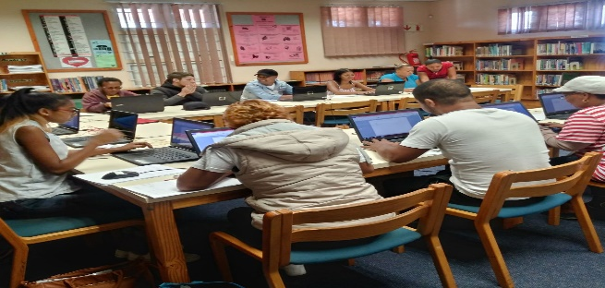

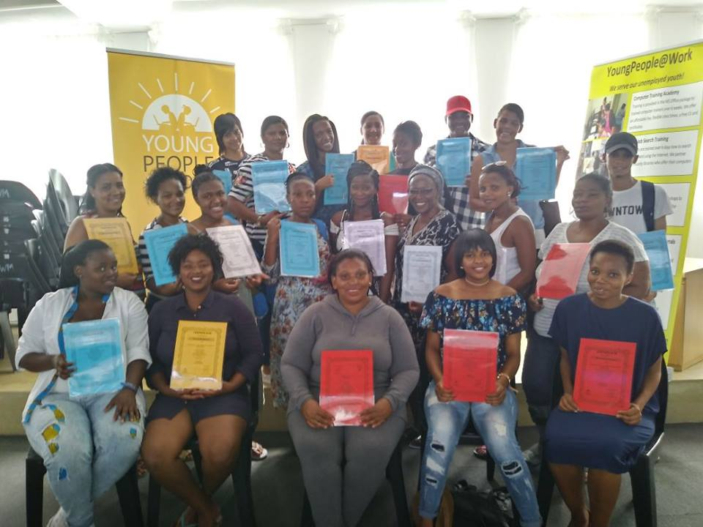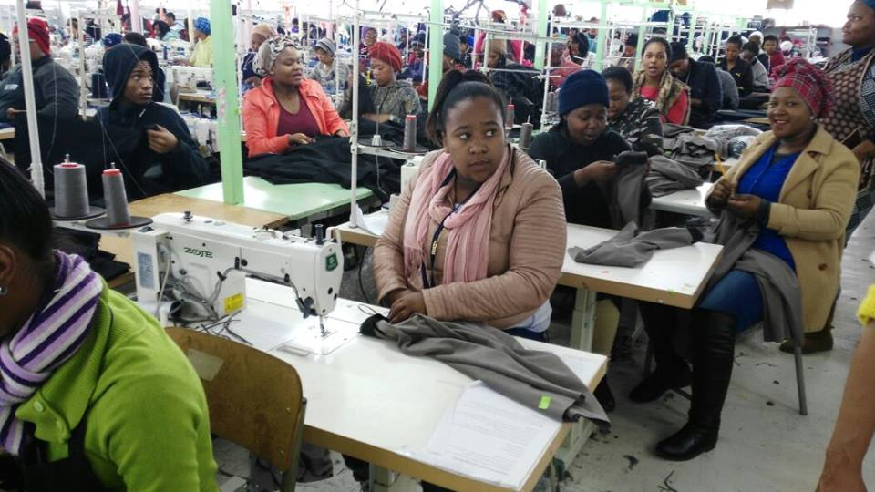

Prepared by: Frank Julie
Executive Director

Contact us here:
5 Hopkins Street,
Parow, 7500
Tel: 021 823 7837
Fax: 021 911 5444
Cell: 073 820 1534
Email: youngpeople.za@gmail.com
Website: www.youngpeopleatwork.weebly.com
“Hello Frank, How are you doing? You are probably thinking after everything I have forgotten about you and the team. Not at all. I am always thinking of you and miss you guys constantly. I miss the interaction and especially your advice. Well, I have great news for you. Better late than never, I have been a casual here and there and basically been head hunted and sometimes they asked me to work from home. My husband's financial manager at Porsche asked me to do some work for a month and ended up being 5 months. A few months later they asked me again. Today I am permanent and guess what last month I bought myself a brand new VW Polo Vivo. I am following my passion and doing administration. I drive the people crazy here with my talking. Thank you for all the support, love and inspiration! Send my regards to Shirley and the team and I miss you guys lots.” (Shaamilah Jassiem – founding volunteer of YP@W)

Introduction:
This is the 5th annual report of YoungPeople@Work (YP@W) covering the period 1 March 2017 – 28 February 2018 and will cover the following:

- The context
- Update on our projects
  - Community Information Sessions/Youth Empowerment Weeks/Life skills courses
  - Online Job Search Training
  - Computer Training Academy
    - Community Investment Programme
  - Job Placement and Tracking
  - Rural Outreach
- Media and Marketing
- Networking
- Fund Development
- Finance
- Office administration
- Board developments
- Other developments
  - Investment in staff/volunteer development
  - Risk factors
  - Strategic focus areas for 2018
  - Summary of investment in our beneficiaries in Rand terms
  - Expression of gratitude

The context
In our previous annual report, we described the context as follows:
“The situation of unemployed youth in South Africa is getting worse! This is despite all government efforts to stem the tide of youth unemployment and despair. Our economy is currently bordering on recessionary conditions with almost zero economic growth. This is exacerbated by large scale government corruption, collusion by huge corporates, daily political revolts and uncertainty, collapse of public services such as education, etc. School leavers are the most vulnerable in this debilitating environment of hopelessness. Almost half a million children drop out of school before matric and educational experts are unanimous that the standard is deteriorating. School leavers are hopelessly unprepared for the world of work!
According to the labour force survey statistics released by Stats SA on a quarterly basis, unemployment is on the increase. Worst affected is the age group between the age 15-35 (the definition of youth in SA) at 62%. This is almost 3 times the rate of unemployment during the Great Depression of the 1920/30s when the highest level of unemployment was recorded at 24.9%! South Africa’s youth are therefore experiencing the effects of 3 Great Depressions every single day! Unable to make sense of this cruel world around them, our youth use escapism as a preferred method of intervention. About 25% of youth are now on drugs and reports suggest that teenage suicides are on the increase!”
The above context has largely remained the same. The change on the political scene within the rural party has created hope of better prospects for unemployed youth. This hope is reinforced by the launch of various initiatives aimed to address their dire situation such as the Youth Employment Service targeting 1 million youth over 3 years in collaboration with corporate partners. Initiatives such as Harambee Youth Employment Accelerator has also been operating for a few years, drawing support from the government Jobs Fund located within the Department of Trade and Industry.
The debate over land expropriation without compensation has also been put firmly in the national agenda. This is a key issue that is linked to the structural nature of unemployment which cannot be avoided. If resolved properly, it will remove a huge barrier to the concentration of wealth and open up prospects for a more open economy with more employment opportunities. As an organisation promoting the interest of unemployed youth, we cannot stand neutral and passive in this debate.
Update on projects:
Community Information Sessions/Youth Empowerment Weeks/Life skills training

- Objective: Train between 500 – 600 unemployed per annum in various locations as part of our approach to facilitate access to opportunities.
- Our life skills intervention is part of offering a holistic intervention to youth unemployment. Instead of just focusing on finding employment and keeping a job, the focus is on finding oneself. The aim is to develop a consciousness of self, understanding life in a rapidly changing and unpredictable world where the job market is in constant flux.
- Our focus is not just to provide a docile labour force to the economy but youth who are critical about the nature of the economy and how it is designed to serve the interest of a few. We also create awareness of rights of employees in line with current legislation protecting them.
- We have discovered that many participants are attracted to our admin and basic bookkeeping workshops. Our approach is to use these workshops as a feeder to our life skills week (other 4 workshops) and computer classes. This has proved very successful and has enhanced our quantitative impact.

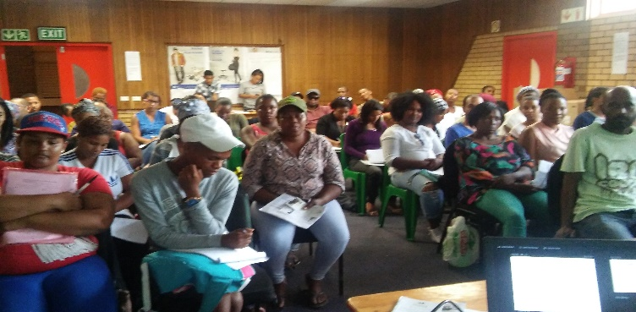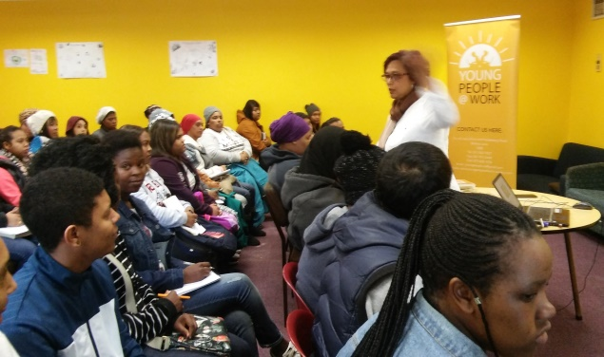

Youth week at Delft library Youth week at Rocklands library

Anita Adams wrote:
"Good day Frank and team! It is Anita I just want to thank you for all the wonderful information you have shared with us. I went for an interview yesterday and it was successful. The little pocket guide you gave us was very useful and the tips on how to make an excellent CV. The interviewers loved my CV and they were impressed with my answers. They even said they wouldn't want to lose me! I will start training on Monday and have also taken the opportunity to volunteer at Tygerberg hospital. You have really motivated me and I now know I can do anything I put my mind to. It feels very good now knowing what I want to be in future and what my goals are."

Training venue | Date | Nr of participants
Bellville Library | 19-20 April 2017 | 103 – 112 = 215
Rocklands Library | 26-27 June 2017 | 40-52 = 92
Khayelitsha | 19-20 July 2017 | 53 – 43 = 96
Grassroots – Athlone | 26-27 July 2017 | 52-46 = 98
Kuilsriver Library | 2 -3 August 2017 | 63-63 = 126
Ithemba Labantu Centre, Phillipi | 16-17 August 2017 | 49 – 46 = 95
Delft Library | 23-24 August 2017 | 50 – 44 = 94
Suidersee Library, Strand | 13-14 Sept 2017 | 36 – 41 = 77
Eikendal Library, Kraaifontein | 7 & 9 February 2018 | 47 – 46 = 93
Delft Library | 14 & 15 February 2018 | 48 – 61 = 109
Adriaanse Library | 21-22 February 2018 | 34 – 44 = 78
Total nr of participants |  | 1178

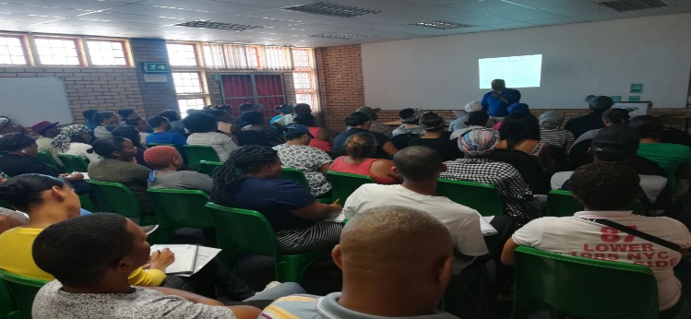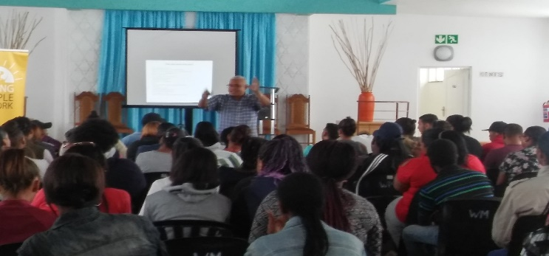
Participants attending life skills workshops in Eikendal library and our Parow training centre

Life skills course:
Venue/Area | Period | Nr Participants
Ravensmead Library | 19-22 June 2017 | 55-70-57-62 = 244
Bellville Library | 31 Oct 1-2 Nov 2017 | 23 – 20 -19 = 62
Whalemark Whale and Marine Museum, Parow | 5- 8 March 2018 | 50-75-74-75 = 274
Total nr of participants: 580

Please note:
Whereas our Youth Empowerment Weeks are more outreach based and mostly over 2 days, our life skills course is more centre based, i.e. hosted at our training centre and usually over 4 days of intensive training with guest speakers. We were able to exceed the target we set ourselves due to the extra funding we accessed. The Department of Social Development also approved a funding contract to train 100 unemployed youth very late in November 2027 enabling us to roll out more workshops.

We were joined at our various workshops by partners such as Activation Agency, Harambee and Reach Make It. Information about partners such as Dreamworker, RLabs, I-College and Kolping SA were shared and referrals made. CVs were also updated and completed. We also targeted new areas such as Phillipi, Mitchells Plain, Kuilsriver and Kraaifontein. We are receiving constant requests on our Facebook page from unemployed youth in the far southern suburbs such as Grassy Park, Retreat, Lotus River, etc. and will respond to it in 2018.

Online Job Search Training
After some serious setbacks suffered in 2016 with cable theft at various libraries, we changed our strategy with this programme. We acquired our own laptops and offered more training at our centre in Bellville. This had the effect of providing access to more unemployed youth from a broader geographical area. The result was a fourfold increase in the number of participants. We varied this with outreach to various libraries in November 2017 and January/February 2018. Our relocation to Parow also boosted attendance due to easier accessibility via the taxi, bus and train routes. Unlike 2016, we also had much fewer drop outs. Our ability to place and refer was therefore also enhanced.

Our objective for 2017 based on our restructuring was to train between 500-600 unemployed youth and assist them with their CVs.

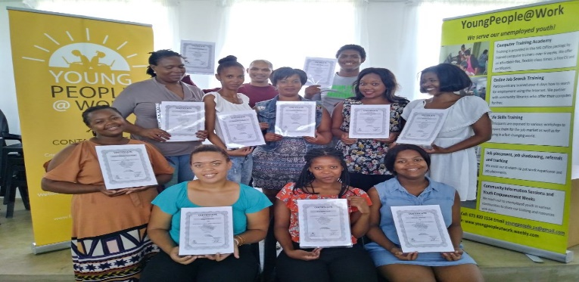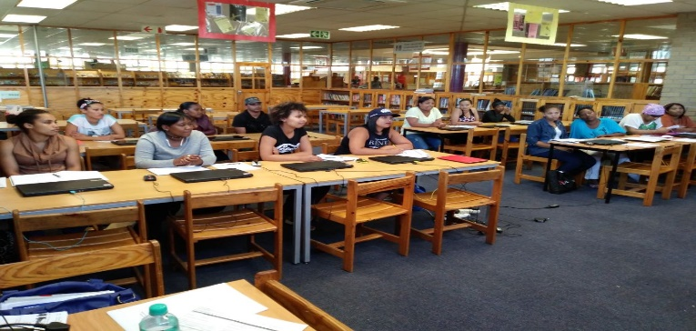

Parow training centre Delft library

Library / training site | Nr of participants
Bellville training centre | 506
Parow training centre (from mid Jan/Feb 2018) | 89
Delft library | 36
Bonteheuwel library | 62
Elsies River library | 21
Parow library | 24
Adriaanse library | 45
Bishop Lavis library | 62
Total | 845

Kathleen Haupt wrote:
My son Chadwin Haupt is 20 years old. He is now doing Assistant Carbon Steel Welder NQF level 2.He dropped out of school in 2015. He failed grade 10.He was @ home for 2 years. We attended YoungPeople@Work workshop in Athlone and was introduced to Reach Make It Welding Academy. We were very impressed. I phoned the Monday just to enquire as we have no finance to start yet. I spoke to Lenie who was so positive. He said" don’t worry about money send him tomorrow, money you can always pay later. Next day he started and Thank God he is a different person. I believe you and your team were God send. I can't thank you enough you saved my child believe me when I tell you!! Thank you from the bottom of my heart and that is from everyone in my family!!

Computer Training Academy

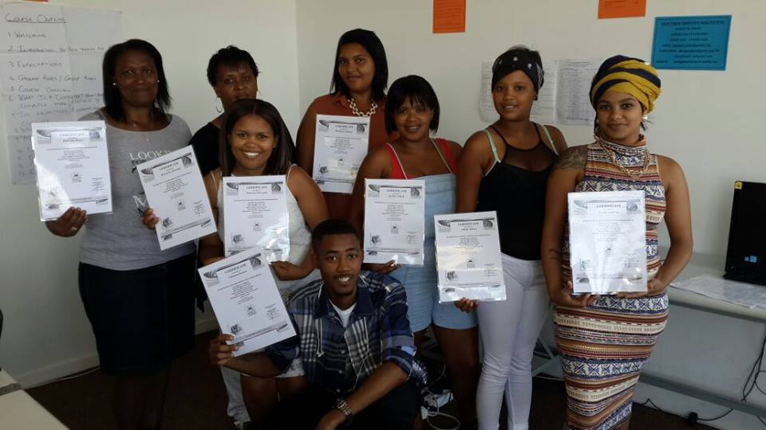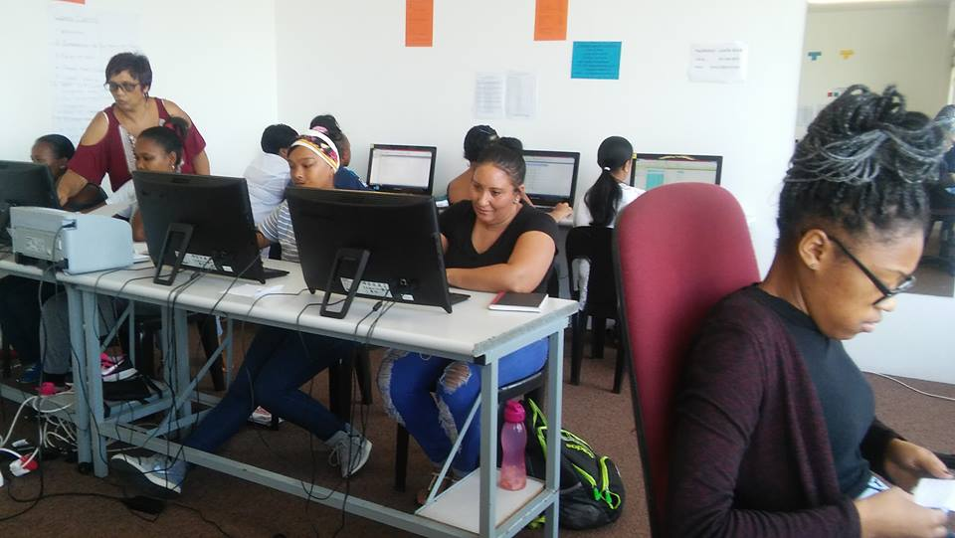

6 week computer course:
We offer a paid 6 week intensive computer course over 4 days per week with 2 hours per session covering Intro to computers, typing skills, MS Word, Excel, Access, PowerPoint and Internet/Email. This programme addresses the demand in the corporate world. This year we were able to complete 6 semesters instead of 4 last year.
Total number of students trained = 146
The above total also includes two Saturday classes. No serious technical problems were experienced with the delivery of this course. Participants were recruited mostly via Facebook instead of newspaper adverts as in previous years.
Community Investment Programme
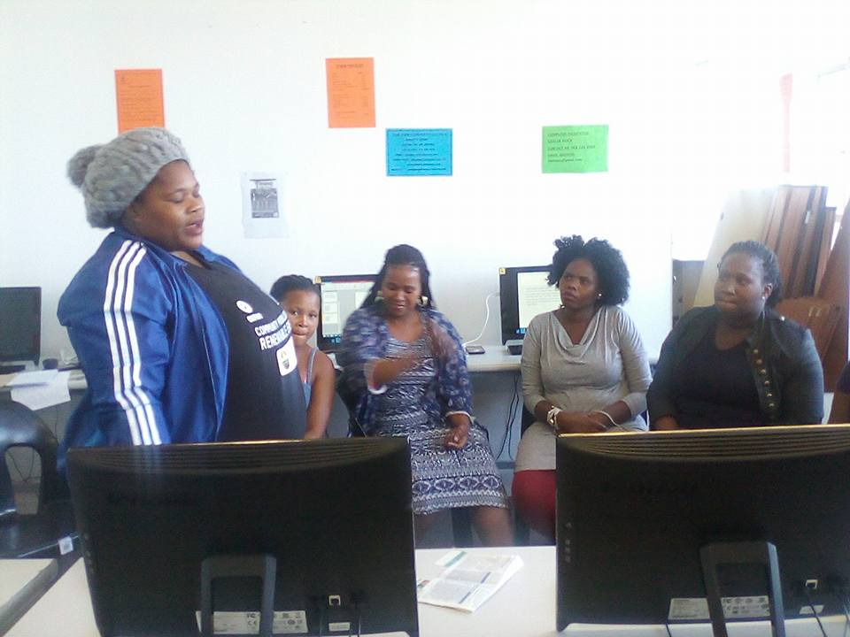 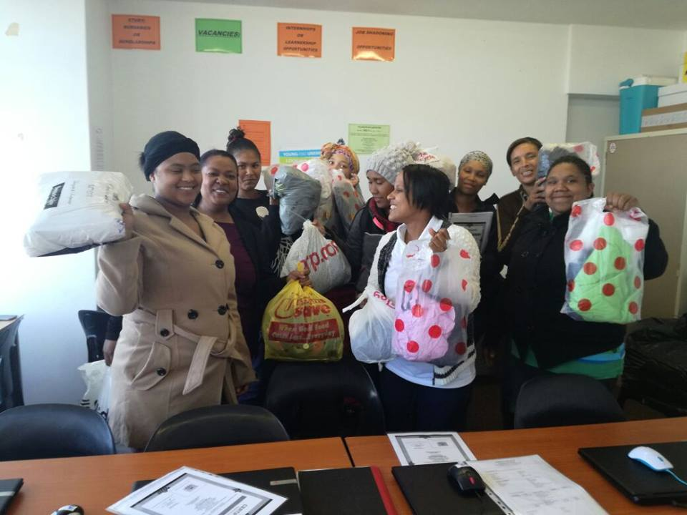
Students from Zanele Women’s Development Students from Sakha Isizwe with material donations
This programme is aimed at organisations whose members are volunteering in their communities and lack the financial capacity to pay for computer training. This year we trained members from the Khayelitsha Women’s Development Forum, Zanele Women’s Development based in Mfuleni and single mothers from the Delft community completing their matric through Sakha Isizwe. The latter group received donations of clothes, material and toiletries sponsored by Rescue Among Many based in Thornton.
The following organisations and individuals benefited from this programme this year:
Organisation | Nr of participants
Sakha Isizwe – Delft | 20
Zanele Women’s Development – Mfuleni | 8
Women’s Development Forum – Khayelitsha | 7
Total | 35

Master Train the Trainer

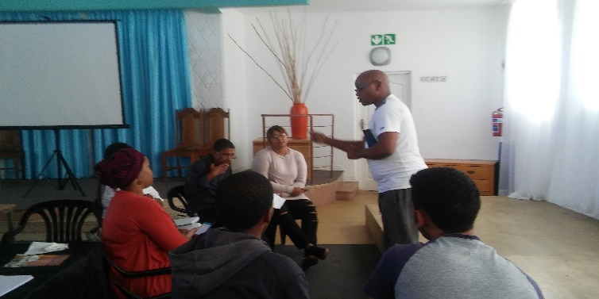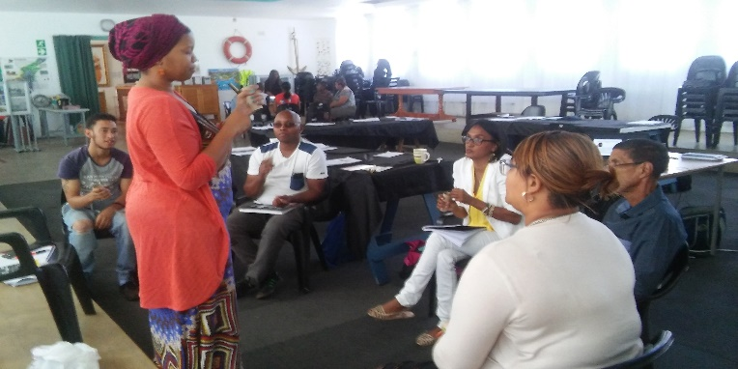

Master TTT hosted at our training centre

Venue | Period | Nr of participants
YP@W Centre, Bellville | 13-15 June 2017 | 4
Bellville Library | 29-31 Aug 2017 | 11
Ikamva Labantu in Khayelitsha | 14-16 November 2017 | 25
Total = 40

Job Placement, tracking, referrals and job shadowing

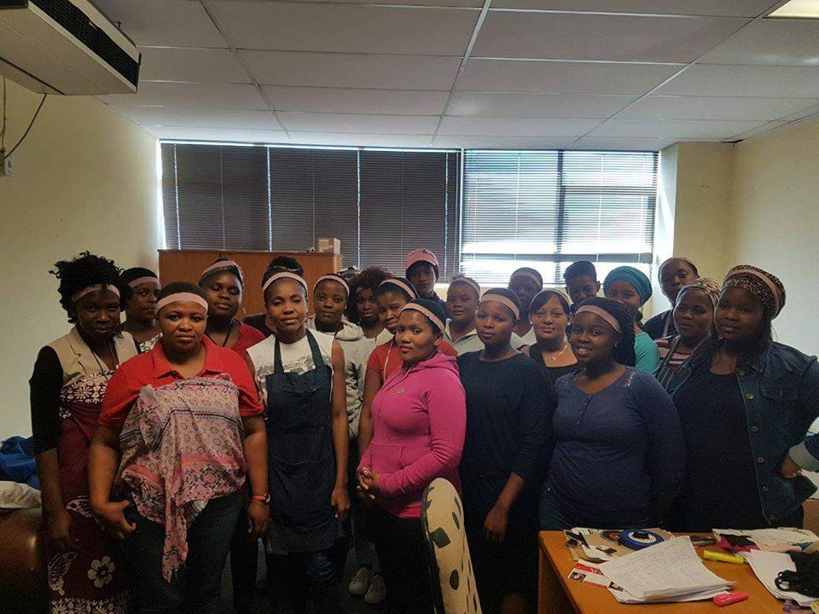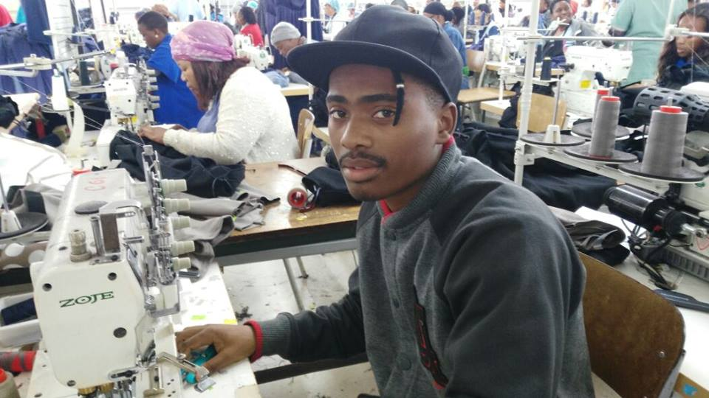

Referrals made to Gerli Clothing in Maitland for a clothing learnership busy on the production line

This year we were able to cement partnerships with Activation Agency focusing on the placement of unemployed youth in finance, insurance and marketing fields and I-College offering bursaries for various one year courses. As we reported last year, we have a tremendous challenge convincing participants on various courses to inform us when they access employment once they complete their training. Our placement and tracking results are therefore not reflective of the maximum number of placements. It only reflects information we have accessed based on our own tracking results, reports from partners and anecdotal evidence.

A summary of placements, referrals, job shadowing and income earned or savings made

Company/organisation | Nature of placements | Nr of placements
Mind Magic | 3rd phase hairdressing learnership completed | 3
Remax Real Estate | 1 referral (paid) R2500 p.m. | 1 intern placed (training is ongoing)
RLabs | Referrals to various social media course | No record of nr of participants due to lack of communication by participants and RLabs
Harambee | Placement of unemployed youth through our various skills training programmes - 1st phase referrals = 91 (until April - June 2017)  2nd phase referrals = 685 (from July 2017 until Jan 2018) (report awaited due to new manager appointed) | 32 – migrated to new platform  17 – did not arrive for 1st phase support programme  17 – not eligible based on criteria  8 – not interested anymore  Other = either employed, study further or await 2nd phase for placement
Dreamworker | Job placements (average income of R3000-R5000 per placement) | 21
Gerli Clothing | Placement in clothing learnership (received a monthly stipend of R1100 per person) over 6 months. Some placements were made permament. Nr to be verified. | 140
I-College | 40 referrals for various courses such as IT (technical), computer training, business admin, office admin, marketing, wealth management, bookkeeping (courses are valued at R30-40 000 per course) Students receive bursaries funded by companies. Whilst this report is prepared, another cohort of participants is in the process of being registered. | 11 registrations confirmed
Kolping SA | 4 referrals (1 home-based care, 2 chef assistant, 1 hairdressing) (bursaries valued at between R4000-R6000 pp) | 4 placed and training completed
Activation Agency | 84 CVs referred | Waiting for feedback (after numerous emails and 2 phone calls)
Other companies | This include Reach Make It Academy, Whalemark Museum, Foschini Group, etc. | 21
YP@W | 4 referred as volunteers | 2 placed as paid fulltime employees (1 admin and 1 training) 2 placed as temporary admin assistants

Job shadowing
Name and field | Organisation and Job Shadow Candidate | Duration
Marchalene Huckins – Org management | Frank Julie | 1 week (started volunteering at Sweet Pea Foundation in Strand)
Eleanor Louw – Org management | Frank Julie | 1 week
Etheline Tyakume – Org management | Frank Julie/ Lizelle Kock | 1 week each
Enoch Kock – Org management | Frank Julie | 1 week
Giovanni Martin – Facilitation | Frank Julie | 1 Week
Shamiela Hendricks- Facilitation | Linda Williams | 3 Days (Accessed employment through Dept. of Social Development in a food security project)
Giovanni Martin –Facilitation | Linda Williams | 1 Week (Accessed employment at Disaster Management as firefighter)
Andile Mphokeli – Facilitation | Linda Williams/ Frank Julie | 1 week (became fulltime trainer at YP@W)
Galieb Williams – Facilitation | Linda Williams | 1 week
Cleo Braaf – Facilitation | Linda Williams | 1 day
Jaydene Africa-Office Admin | Shirley De Jongh | 1 week
Aretha Julie – Facilitation | Lizelle Kock | 2 weeks
Shaneeka Abdullah – Facilitation | Lizelle Kock | 2 days (currently works at Red Cross hospital as office assistant)
Jordan Williams-Office Admin | Shirley De Jongh | 1 week
Kelley-Leigh Oliver-Office Admin | Shirley De Jongh | 1 week
Eresona September – Office admin | Shirley De Jongh | 3 weeks
Rene Van Der Walt – Office admin | Shirley De Jongh | 1 week
Lee-Ann Titus – Office admin | Shirley De Jongh | 1 week
Caroline Prinsloo – Office admin | Shirley De Jongh | 1 week
Chante Rass – Org Management/HR | Frank Julie | 1 week
Patience Matsolo- Office admin | Shirley De Jongh | 3 Weeks
Unathi Mhloyane- Office Admin | Shirley De Jongh | 3 weeks
Donato Hansby-Facilitation | Linda Williams | 1 Week (access permanent employment at Woolworths, Canal Walk)
Chante Rass – Intern | Shirley de Jongh | 18 month internship (placed by Boland College)
Cameron Van Wyk – Org management | Frank Julie | 2 weeks (referred to Northlink College for 1 year motor mechanic course – full bursary)
Total nr of job shadowing opportunities |  | 25 (In 2016 = 7)

Observations
Due to challenges faced in placing our participants for job shadowing with other partners, we decided to increase the number we can accommodate within the organisation. Hence we resolved that each staff members should reach a target of at least 5 participants for job shadowing. We plan to pursue this objective again in 2018. A call was made on Facebook in January 2018 for NPOs to host participants for at least a week. About 10 responses were received and followed up but no opportunities materialised so far.

Rural Outreach
Due to financial constraints we decided not to visit the 3 rural areas as planned. We were invited by Change Agents, a NPO focusing on drug abuse and rehabilitation, to host a life skills week in Montagu/Ashton. We also used the opportunity to do our mid-year strategic assessment.

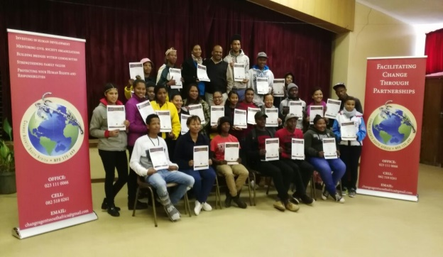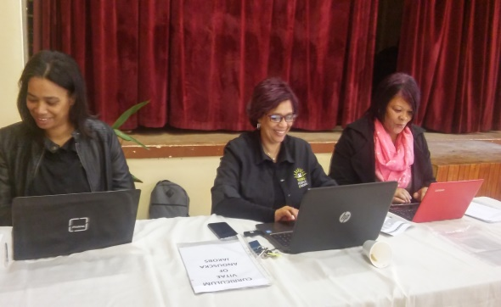

Area | Activity
Montagu/Ashton | 3 day life skills workshop from 2-3-4 July 2017 for 35 participants

Shamiela Hendricks wrote:
I’m Shamiela Hendricks and I have completed my Master Train the Trainer course during last week and this was a bursary given to me by YoungPeople@Work for which I am entirely grateful!!! Thank you guyz!!! The experience to me was really, without doubt, amazing… one of the best training sessions I have ever experienced. We were informed that, on completion it would be best if we job shadow one of the trainers of YoungPeople@Work.

Firstly, what was to me unique was the fact that I have attended and completed many trainings before, but it’s the 1st time I have had the organization allow the participants the opportunity to job shadow after training. I was astounded as this was definitely an ADDED BONUS on my end!! Secondly, one would think that the trainers or facilitators would feel uncomfortable, having someone sit in on their sessions and watch them as they train or facilitate…but to my surprise trainers actually suggested we watch them train, which indicated the confidence they have and not shying away from being scrutinized… ANOTHER WOW!!

Media and Marketing
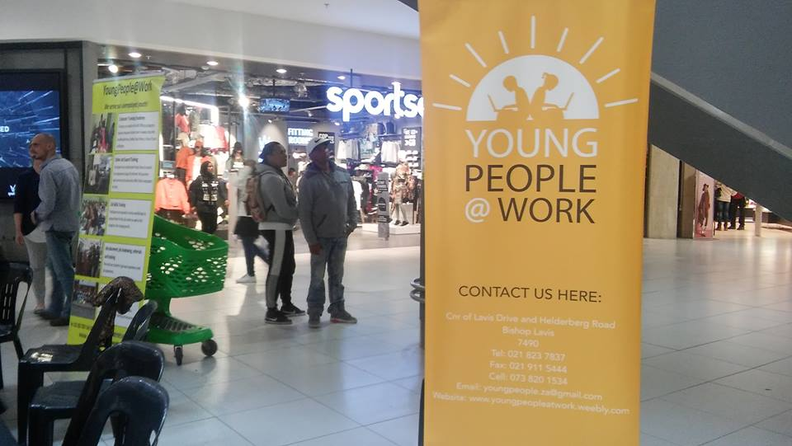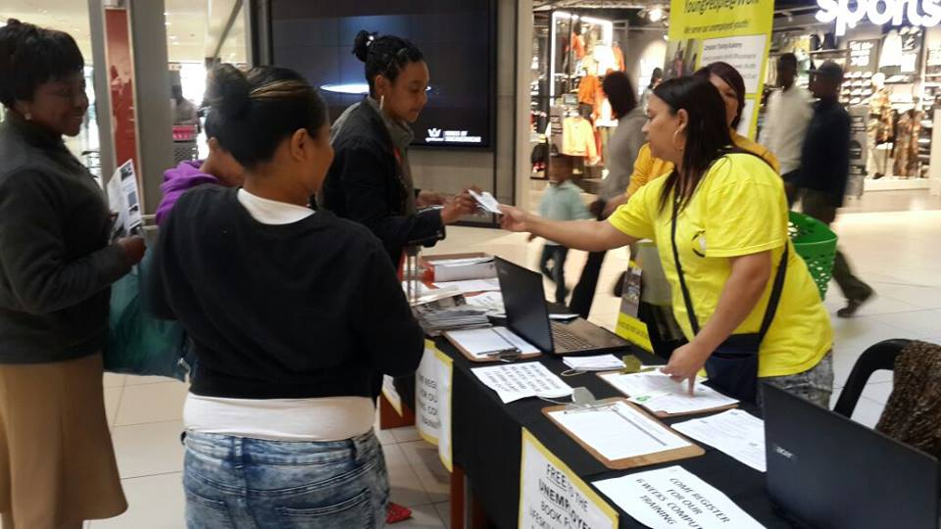

Staff, volunteers and board members were all active during an exhibition at Parow Mall in September 2017

Marketing medium | Quantity and focus | Area covered
Pamphlets | No new pamphlets printed; old pamphlets copied | Shared in workshops
Murals | No murals added this year | n/a
Radio interviews | 2 interviews focusing on programmes for unemployed youth (Radio 786)  Interview on Smile Radio | Cape Peninsula  Cape Peninsula
Electronic newsletter | 3 editions focusing on youth issues, programme developments and YP@W success stories | 2000 subscribers nationally; another 700 subscribers added in 2017
Website | Continuous updating focusing on YP@W programmes | National and international
Facebook page | Daily updates on YP@W developments, success stories and job opportunities | Current followers: 20 000 until Feb 2018 (9862 followers – Feb 2016)  (4482 followers – 2015) regionally, nationally and internationally
Newspapers | Tygerburger, Peoples Post and Athlone News – promoting youth weeks, computer and life skills workshops | Free articles covering our life skills training and free online job search training
Block emails | Advertising our computer and life skills courses | Targeting mostly NPOs with youth volunteers
Whatsapp groups | Advertising our computer and life skills courses and advanced training; also started sharing with many other pages hence the phenomenal increase in our followers in 2016 | Targeting participants, ex-participants, walk-ins and youth empowerment week participants
Word of mouth | Advertising our computer and life skills courses and job opportunities | Continuous and our main marketing medium based on participant surveys in workshops and application forms
Exhibition | 1 exhibition sharing info about YP@W programmes; partner programmes and registering participants for our courses; completing CVs | Parow Centre (Mall) targeting unemployed youth from the northern suburbs
Brochures | Old copies still in stock | Distributed at YP@W workshops and exhibition
Profile document | Reflective doc detailing the background and methodology of YP@W | Constantly updated and distributed to various stakeholders on request

According to a survey conducted amongst our participants, the most popular mediums to find out about YP@W are:
Facebook , Newspaper (articles and adverts), Word of mouth, Pamphlets, Murals, Radio, Others

Our marketing monitoring indicates that about 80% of all our participants accessed information about our programmes via Facebook. This trend started last year and is deepening as we doubled our following. We have stopped advertising in community newspapers, saving us at least R14 000.

Networking
Our current network partners are:

Partner | Investment made
RLabs Social Media Academy and Youth Café | Free scholarships for social media training
Harambee Youth Employment Accelerator | Referrals for jobs at mostly retail companies
Dreamworker | Referrals for jobs
Western Cape Youth Development Forum | Networking and exposure of our programmes in the bi-weekly newsletter
I-Can technology centre | Free bursaries for IT and social media training
Bellville library | Hosting of Youth Empowerment Weeks/Life skills training and 2 Master TTT.
Delft, Adriaanse, Bishop Lavis, Bonteheuwel, Elsies River, Parow, Suidersee (Strand) Eikendal libraries (Kraaifontein), Whizz ICT (Blue Room), Grassroots (Athlone), | Hosting either the free online job search training and youth empowerment weeks or both
Kolping SA | Access to free bursaries for further training in office admin, catering (chef), home based care, ECD, hospitality, plumbing
Whalemark Museum (Parow) | Hosting 1 Master TTT and free online job search training as well one life skills course over 4 days.
I-College | Referrals to accredited one year courses
Gerli Clothing (Maitland) | Referrals to clothing learnership
Activation Agency | Referrals to employment in finance, marketing and insurance industry
Reach Make It | Referrals to welding and plumbing training
Ridhaah April wrote:
“Hi Frank I am one of the volunteers who worked with Linda Williams at Bergville Primary School. (The one in the wheelchair) I received a bursary from you with the help of Linda for the Master Train the Trainer course. I found it so informative and it boosted my self- confidence to the extent that I've applied for a job at the City of Cape Town and out of 21 people I got the permanent position. They told me afterwards that one of the deciding factors was the course I did with you guys as that will form part of my job description. I am so grateful for everything you've done for me and your talks truly inspired me tremendously! Many thanks!”

Fund Development
The following is a summary of funding received and proposal submitted:

Donor | Amount requested | Status
Kerk in Acktie | R300 000 | R280 000 (due to fluctuation in exchange rate)
National Lottery Commission | R450 000 | R107 000
Department of Social Development | R250 000 | R125 000
King Baduoin Foundation (Belgium) | R100 000 | R50 915
Community Chest – Western Cape | R100 000 | R50 000
Total amount |  | R612 915 (R338 740 - 2016) (R149 692 - 2015)
Funding applied for
Pick n Pay | R30 000 | No response
HCI Foundation | R70 000 | Declined
Magi Fund | R170 000 | Declined
Investec | R30 000 | No response
Heart Foundation | R30 000 | No response
African Women Development Fund | R300 000 | Application acknowledged – waiting for final feedback

Please note:
We have been relatively successful this year with accessing external donor funding. 4 new donors were recruited. KBF was a lapsed donor from 2015 who again came on board. Kerk in Actie indicated that they will continue funding us for another 2 years. This core funding is critical to cover our main overheads and programme expenses. The DSD also indicated during their evaluation visit on 1 March 2018, that funding can be renewed based on our exceptional results. We were also visited by Gert Jan Pieterse from Holland who is the founder of the Forza Foundation to explore a funding partnership.

Own income generation

Income streams | Amount
6 week computer training fees, USB sales, computer manuals | 110 665 (125 946 - 2016)
4 days online job search training (include CVs and certificates) | 15 852 (we started charging since in 2017)
Workshop fees, manuals, CV typing, printing | 35 410 (16 214 – 2016)
Individual donations (Facebook appeals and monthly debit orders) | 17 871.89 (37 290 – 2016)
Admin fees from referrals to Gerli Clothing and Activation Agency | 9500 (we started charging admin fees in 2017)
Volunteer and board contributions (for daily tea and coffees) | 660 (1780 – 2016)
Interest from notice account | 17 910 (4099.17 – 2016)
Subtotal | 207 868.89 (179 723 in 2016)
Material donations (and donations in kind) and estimated value
Hoosain Adam (Holistic Financial Services) | 1 free money management workshop (at Ravensmead library) x 3000 = 3500
Choose Life Businesses | Bookkeeping and accounting services @ a saving of 2000 p.m. x 12 = 24 000
Whalemark Museum | Saving on monthly rental @ 5000 p.m. x 12 = 60 000 (2 offices and free access to a hall for training space)
Saving on director’s salary (market rate is 25 000 p.m. but current rate is 7000 p.m.) | Saving made: 18 000 x 12 = 216 000
Access to community library halls for life skills training and online job search training (excluding Parow library) | Workshops x 500 per day x 63 days = 31 500
Donation of 10 office desks and copier and fax machine | @ 1000 per desk x 10 = 10 000 + 1000 (copier/printer/fax) = 11 000
Subtotal | 346 000
Total amount of income generated | 553 868.89

Please note:
- Our target for 2017 was to raise R200 000. We have exceeded this target with R7868.89.
- Our 6 week computer course income declined again due to our inability to offer evening classes due to our location which require access to transport. This was mitigated by our new income streams such as charging for online training CVs and certificates as well as admin fees for referrals and placements.
- Our income from individuals was also under pressure. This was partly due to a weak response via Facebook as well issues with debit orders from two sources.
- Due to proper financial projections, we were able to maximise interest from our notice account. Request for release of money to pay unforeseen expenses is also immediate and incur no penalties unlike FNB where the account was previously held.
- We have made a substantial saving with relocating or office to Parow with all the additional benefits of access to parking, training space (including life skills), saving in transport for staff and students.
- Our partnerships with the community libraries with access to their computers, wifi and halls, are savings us thousands of rand.
Finance
Our bookkeeping has been outsourced to Choose Life Businesses managed by Cheryl-Lynn Roziers who has been an active supporter. We only pay a small fee of R350 per financial report submitted each month. She also completed our annual financial statements as required by the Companies Intellectual Property Commission (CIPC) where we are registered. We also acquired insurance from Santam for all our assets. We visited the Department of Labour in November 2017 for registration on their unemployment insurance fund. This was after they visited our offices (still in Bishop Lavis in 2016) to assist us. We were advised that only online applications are processed. This was done but after 6 months we are still waiting for feedback.

Our tax submissions were finalised by our accountant and are currently up to date with a SARS tax clearance certificate that was issued. We are still struggling since 2015 to finalise our PBO application with SARS tax exemption unit despite many attempts from our side. After a long silence from SARS we have reactivated the contact and has a new person dealing with our application, requesting documents submitted ages ago. We hope to finalise the application this year after resending two final documents recently.

We have changed our 32 day notice account to Nedbank after Investec stopped its services to HGG. We received more or less the same benefits.

Our computer fee collection is still very efficient with almost 90% collection rate. Our introduction of payment for certificates and CVs last year has led to a new income stream. The saving of 50% on our monthly rental is another huge income for the organisation since we are able to invest this in more infrastructure like laptops and hence train more unemployed youth.

Internal auditing:
Our director undertook this process as part of our culture of continuous improvement. In September all office admin and finance systems were evaluated. This included scrutinising various programme documents such as attendance registers, course framework, payment agreements by students, receipt books, cheque requisitions, etc. Subsequently staff members were consulted and recommendations made for improvement of systems and procedures.

Office administration
Relocation to Parow:
We decided to relocate our offices and training centre to Parow in January 2018. The benefits were as follow:
- A 50% reduction in our monthly rental (including water and electricity)
- Easier access for our staff and students as well reduction in transport fees
- No worries of lift challenges as experienced in the previous building
- More training space available especially for online training
- Admin and training space were separated
- More access to free parking for staff, partners and students

We acquired uncapped high speed Wifi which means we are now able to be connected to the Internet all the time. This is huge help for our online job search training classes. All staff members have their own laptops for admin work. We restructured our class times to allocate a 1.00 p.m. – 4.00 p.m. slot for admin, staff development and tracking purposes. Tracking is now done continuously during this time slot. The slot is also used for computer training for participants on our Community Investment Programme when necessary.

Board developments
The board met 3 times this year. No new members joined the board. After our board evaluation in the beginning of 2017 we decided on the following board changes:
Chairperson – Estelle Hendricks (previously treasurer)
Vice-chairperson – Victoria Petersen (previously just a member)
Marileze Johannes – Treasurer (previously chairperson)

A board development workshop was facilitated by Frank Julie on 21 April 2017 after a request from board members. It was also recommended that board and staff meet at least once per annum in a social context. This must still be executed. Monthly membership fees are not paid consistently by board members. This issue was addressed by the board.

Staff/volunteer development

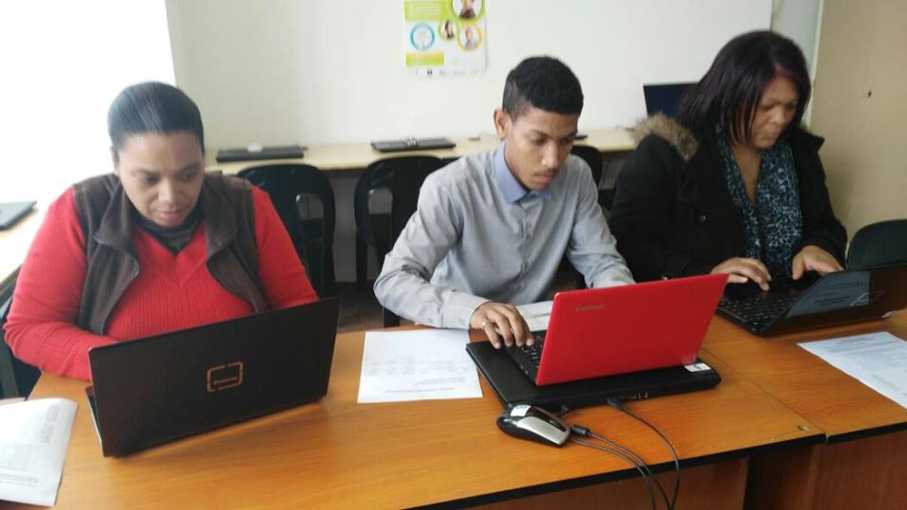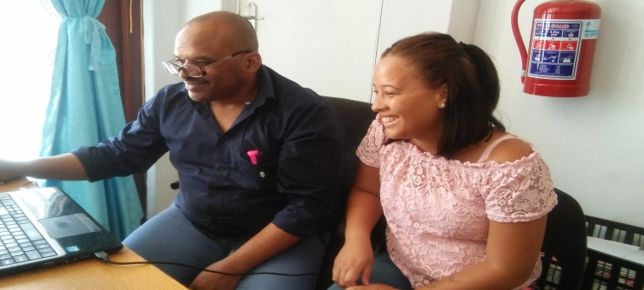
Staff members busy with advanced training Chante Rass job shadowing Frank Julie

Staff members and volunteers were exposed to the following training:

Activity | Facilitator
Intermediate and advanced Ms Word and Excel (still in progress) | Shirley De Jongh
The effective NPO executive workshop attended by Lizelle Kock, Linda Williams and Shirley De Jongh | Frank Julie
Job shadowing of Andile Mphopkile | Frank Julie
Driving lessons for Linda Williams and Lizelle Kock | Wayne Driving School
Mentoring of Chante Rass | Shirley De Jongh
Job shadowing of Chante Rass | Frank Julie
Mentoring of Linda Williams in office admin | Shirley De Jongh
Lizelle Kock, Shirley De Jongh and Linda Williams attended the Master Fundraising Mentoring Forum | Frank Julie
Shirley De Jongh presenting “Managing Funding Gaps” at the MFMF | Frank Julie
Frank Julie enrolled for PHD classes at Stellenbosch University | Frank Julie
Linda Williams obtaining SDF accredited certificate and results | Primeserv
Shirley De Jongh and Lizelle Kock finalising SDF submissions | Primeserv
Effective customer relations session for staff | Frank Julie
Workshop on Foreign fundraising attended by Frank Julie | Jill Ritchie
NPO legal compliance and building an organisation from scratch attended by Shirley De Jongh | Abdul Ryklief (DSD)
Workshop on financial management attended by Linda Williams, Lizelle Kock and Shirley De Jongh | Cheryl-Lynn Roziers (Chooselife Businesses)
Shirley De Jongh | Continuous mentoring by Frank Julie in financial planning and projections
Shirley De Jongh | Coaching by Frank Julie in work plan development and reporting
Shirley De Jongh | Continuous mentoring in donor management and reporting
Staff responsibilities and changes

Frank Julie – Executive Director (March 2012) | Org management, external fundraising, training of trainers, marketing, board development, staff evaluations, networking, transport, banking, shopping, financial planning, reporting, strategic planning, life skills facilitation, rural outreach
Shirley De Jongh (Aug 2012) | Bookkeeping, job placements and tracking, online and 6 week computer course facilitation, office admin facilitation, admin and workshop bookings, online and computer class bookings, minute secretary for board meetings, workshop coordination and logistics
Lizelle Kock (Jan 2014) (Resigned February 2018) | Online and 6 week computer course facilitation, assistant job placement and tracking, workshop assistant
Linda Williams (appointed 1 Feb 2017) | Online computer facilitator, workshop and admin assistant, (6 week course facilitation in progress)
Giovanni Martin appointed August 2017 (resigned February 2018) | Assistant online training facilitator
Chante Rass (appointed as intern in Jan 2018) | Admin assistant (was trained by Shirley De Jongh)
Andile Mphokeli (appointed in February 2108) | Online computer facilitator (training in progress)

Other developments

Risk factors
- Funding (we need to consolidate our external funding base and recruit at least two more donors to replace the Lotto, ending July 2018 and KBF from Belgium which ended in March 2018)
- Staff retention (we need to further consolidate our current staff; the loss of two key staff members in February 2018 was a huge blow; we may have to recruit two more paid volunteers as back-ups in case of unforeseen resignations.
- As stated in the previous report, the part-time director needs proper remuneration to ensure a stronger focus on YP@W management) Fulltime work results have to be delivered on a part-time basis currently.

Strategic focus areas for 2018
- Further expand the external funding base and further deepen our own income base. Review computer current computer fees and launch new income streams.
- Employ two more part-time staff members to alleviate pressure on existing staff
- Increase the level of placements and referrals by developing more partnerships to maximise impact.
- Improve documentation of placements and referrals through our partners.

Summary of investment in our beneficiaries in Rand terms:

Programme/activity | Quantity and average market rate | Average Investment
6 week computer course | 146 participants x 3000 pp = | 438 000
Online job search training | 845 participants x 1000 pp = | 845 000
Master Train the Trainer | 40 participants x 1500 pp = | 60 000
Community Investment Programme | 35 participants x 1000 pp = | 35 000
Rural Outreach Programme | 35 participants x 3 days x 350 pp = | 36 750
Youth Empowerment Weeks | 1178 participants x 350 pp = | 412 300
Life skills course | 580 participants x 350 pp = | 203 000
Total investment through skills training |  | 2 030 050

Conclusion and expression of gratitude
Similar to last year, this was a very tumultuous period for the organisation. After the loss of staff in early 2017 we were able to recover with the appointment of two new members, allowing us some stability. The accessing of 3 new donors assisted us in delivering much more than we planned in terms of our targets in the various programmes. The deepening of our marketing reach has led to an enormous interest in our programmes from unemployed youth reflected in the numbers attending our programmes.

The extra funding also allowed us to expand our infrastructure and provide more quality services. Some weaknesses however still remain especially in the placement and referral department where our partners play a critical role in assisting us with monitoring and evaluation. This area needs serious attention. Despite another unexpected loss of two key staff members early this year, we still managed to recover without disrupting our programme delivery. This speaks to our inherent resilience and flexibility to meet unforeseen challenges.

We wish to once again thank our donors for their generous support, both financial and material, in support of our mission to empower unemployed youth to access decent employment!

We thank you
Frank Julie
Executive Director
20 April 2018

