YoungPeople@Work
Reg. nr: 2012/210099/08 NPC

We live to work – We don’t work to live!

ANNUAL REPORT
Period: 1 March 2018- 28 February 2019

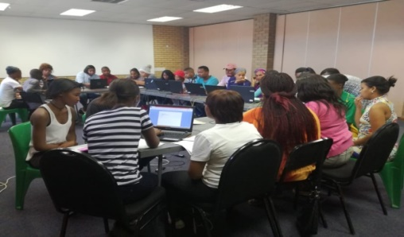

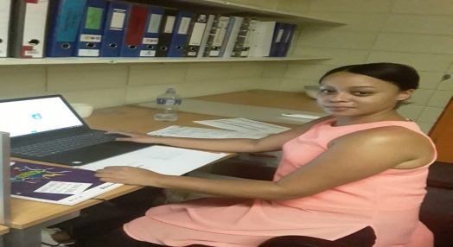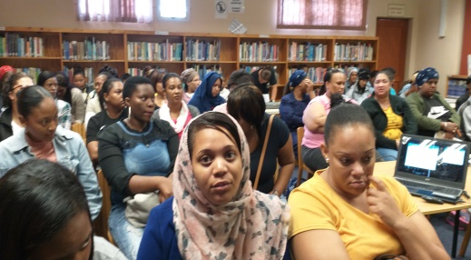

Prepared by: Frank Julie
Executive Director

14 April 2019
Contact us here:
5 Hopkins Street,
Parow, 7500
Tel: 021 823 7837
Fax: 021 911 5444
Cell: 073 820 1534
Email: youngpeople.za@gmail.com
Website: www.youngpeopleatwork.weebly.com
Introduction:
This is the 6th annual report of YoungPeople@Work (YP@W) covering the period 1 March 2018 – 28 February 2019 and will cover the following:

- The context
- Update on our projects
  - Community Information Sessions/Youth Empowerment Weeks/Life skills courses
  - Online Job Search Training
  - Computer Training Academy
    - Community Investment Programme
  - Job Placement and Tracking
  - Rural Outreach
- Media and Marketing
- Networking
- Fund Development
- Finance
- Office administration
- Board developments
- Other developments
  - Feedback from participants
  - Investment in staff/volunteer development
  - Risk factors
  - Strategic focus areas for 2019
  - Music Academy for Rural Youth and Master Fundraising Network
  - Summary of investment in our beneficiaries in Rand terms
  - Conclusion and expression of gratitude

The context
On the external front and based on our previous annual report, nothing much has changed for unemployed youth. The government’s Job Summit in August last year was an indication that unemployment was put in a more serious spotlight. However, lots of scepticism accompanied the event about the ability of government to deliver. The commitment of government to create less than 300 000 new job opportunities was disappointing. In fact, the recent jobs data reveal an increase in unemployment to over 27% (official rate) and close to 35-40% (expanded rate). For youth between the age of 18-26 years the rate is above 50%. Thousands of job seekers who completed matric have now joined the army of unemployed.
On the internal front, we have seen a huge increase from youth attending our various programmes, especially the free ones. The loss of two trainers last year in February placed immense pressure on our existing staff especially since we decided not to appoint new staff but to reorganise our work to save the two salaries to boost our reserves. Despite the pressure however, we manged to pull through and had one of our most exciting years so far, reaching thousands of unemployed youth despite our limited resources.
Update on projects:
Community Information Sessions/Youth Empowerment Weeks/Life skills training

Our life skills intervention consist of 3 programmes namely our Community Information Sessions (CIS) 2 day Youth Empowerment Week or 4 day Life skills week. The CIS is also known as an Open Day where we invite partners to share their employment or training opportunities. These workshops cover the following: Intro to what is YP@W, professional job seeking skills, customer relations, personal development, basic office and finance skills and effective money management. Our target this reporting period was to reach between 700-800 youths. CVs are also updated and certificates awarded. We have made this outreach programme a serious focus and travelled to a number of new communities this year. These included Manenberg, Hanover Park, Strand, Elsies River, Heideveld and Langa.
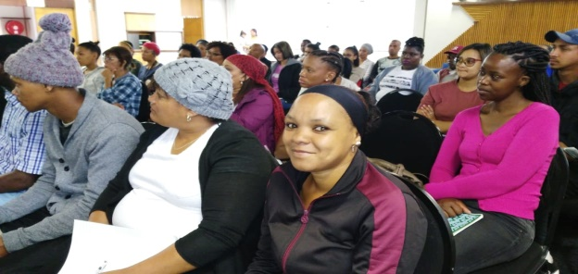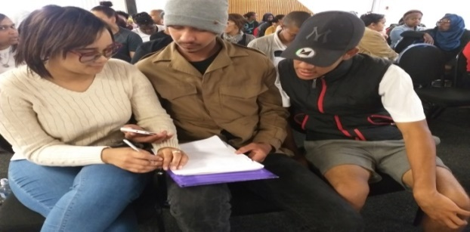

Life skills workshops at various libraries
Library / Training site | Date | Nr of participants
People’s Centre Manenberg | 14 Sept 2018 | 48
Grassroots Educare Trust | 11 October 2018 | 17
Heideveld Library | 26 October 2018 | 32
Hanover Park Library | 8 November 20018 | 40
Suiderstrand Library | 27 November 2018 | 40
Total | Nr of days = 5 | 177 Total fees: R763.00

- Fees were only charged for certificates but not for CV printing and design.

2 DAY YOUTH EMPOWERMENT WORKSHOP
Venue | Dates | Nr of participants
Grassroots Educare Trust | 2-3 May 2018 | 23– 50 = 73
Beacon Valley Frail Care Centre | 23-24 May 2018 | 70-59 = 129
Elsies River Library | 21-22 June 2018 | 42 - 39= 81
Kuilsriver Library | 13-14 June 2018 | 19-12= 31
Delft Library | 30-31 July 2018 | 72-74 = 146
Langa Library | 28-29 August 2018 | 20 – 28 = 48
Whizz ICT Centre, Khayelitsha | 5-6 Sept 2018 | 24 -34 = 58
Total | Nr of days = 14 | 566  Total fees: R9 010.00

Venue | Dates | Nr of participants
Parow Library | 29 October - 1 November 2018 | 58 - 56- 62 -52=228
Bonteheuwel Library | 26 -29 November 2018 | 13 -16 -19-18 = 66
Parow Library | 28-31 January 2019 | 38-32-32-41 =143
Bishop Lavis | 4-7 February 2019 | 35-41-34-31 = 141
Total | Nr of days = 16  Total = 35 | 859  Total fees: R9 836.00
Computer literacy training
This training is executed in 3 different programmes namely the Online Job Search Training (4 days intensive), 6 week computer course (24 days) and the Community Investment Programme.(8 days).

Online Job Search Training
Our change in strategy in 2017 by using our own laptops to become less vulnerable to cable theft at libraries is continuing to pay off. This was despite the fact that we largely only had one computer facilitator manging the programme. Based on our ability to reach 850 beneficiaries last year, we set a new target of 1000. We exceeded this target as our stats indicate. This programme trains participants in basic computer literacy and assist them with their CVs. Referrals to various opportunities are also made. Many participants graduated from this programme to our 6 week paid computer course, making it unnecessary for us to advertise in newspapers at a substantial fee.

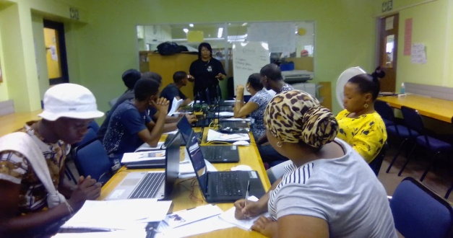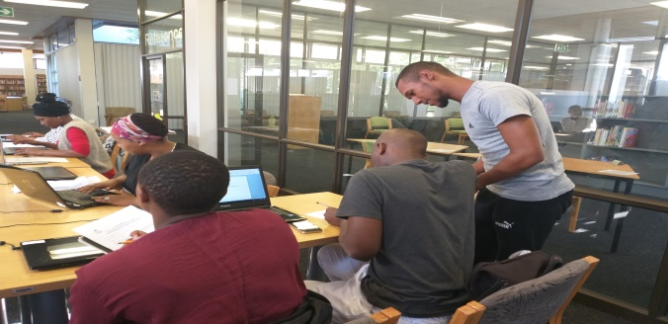

Online job search training in progress at various libraries

4 Day Online Job Search Training
Training Venue | Date | Nr Of Participants
Whalemark Museum, Parow | 12-13 & 15 March 2018 | 16
Bishop Lavis Library | 19-20 & 22 March 2018 | 23
Whalemark Museum, Parow | 26-29 March 2018 | 16
Whalemark Museum, Parow  YP@W Computer Lab, Parow | 9-12 April 2018  9-12 April 2018 | 13  6
YP@W Computer Lab, Parow | 23-26 April 2018 | 7
Bishop Lavis Library | 2-4 May 2018 | 15
Delft Library | 7-10 May 2018 | 28
Elsies Library | 14-17 May 2018 | 31
Adriaanse Library | 21-24 May 2018 | 39
Kuilsriver Library | 28-30 May 2018 | 45
Elsies Library  YP@W Computer Lab, Parow | 4-7 June 2018 | 9  7
Gugulethu Library | 11-12 & 14 June 2018 | 25
Belhar Library | 18-21 June 2018 | 48
Grassroots Educare Centre | 25-28 June 2018 | 38
Parow Library  YP@W Computer Lab, Parow | 2-5 July 2018 | 15  10
Bellville Library | 9-12 July 2018 | 31
Ravensmead Library  YP@W Computer Lab, Parow | 16,17 & 19 July 2018  Same as Above | 23  3
Bonteheuwel Library  YP@W Computer Lab, Parow | 23-26 July 2018  Same as Above | 28  5
Adriaanse Library | 6-8 August 2018 | 5
Elsies River Library | 14-16 August 2018 | 23
Bishop Lavis Library | 20-23 August 2018 | 17
Hugenote Square, Belhar | 3-6 September 2018 | 80
Elsies River Library | 17-20 September 2018 | 29
Kuilsriver Library | 25-27 September 2018 | 38
Bishop Lavis Library | 8-11 October 2018 | 25
Adriaanse Library | 15-18 October 2018 | 24
Delft Library | 22-25 October 2018 | 50
Parow Library | 13-14 & 16 November 2018 | 22
Bellville South Library | 19-22 November 2018 | 34
Manenberg People Centre | 26-29 November 2018 | 28
Elsies River Library | 14-17 January 2019 | 28
Delft South Library | 21-24 January 2019 | 39
Adriaanse Library | 28-31 January 2019 | 39
Delft South | 4-7 February 2019 | 26
Belhar Library | 11-14 February 2019 | 59
Bishop Lavis | 18-21 February 2019 | 36
Parow Library | 25-28 February 2019 | 40
Total participants | Total nr of days = 139 | 1123 (845 in 2017)  Fees: R26 459

Computer Training Academy
- 6 week computer course

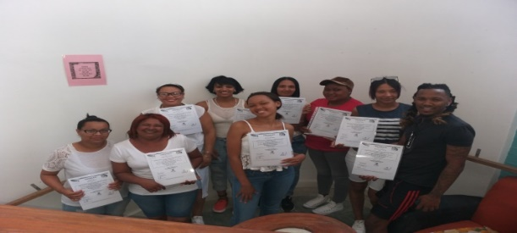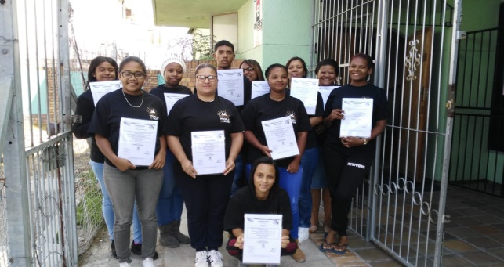

Period | Training Venue | Dates | Total Completed
1st Semester | Parow Computer Centre- Weekly  Parow Computer Centre-Saturdays | 12 Feb - 22 March 2018  10 Mar - 14 Jul 2018 | 6  7
2nd Semester | Parow Computer Centre | 5 March – 17 April 2018 (morning and afternoon slot)  4 August – 17 Nov 2018 (Sat slot) | 8 + 7 = 15  7
3rd Semester | Parow Computer Centre | 23 April - 12 June 2018  28 May - 12 July 2018 | 15 ( include 2 x bursaries)
4th Semester | Parow Computer Centre  (This includes Morning and Afternoon slot) | 9 July - 23 August’18  23 July -5 September 2018 | 13 ( include 1 x bursary & 1 student paid 50%)
5th Semester | Parow Computer Centre | 27 Aug - 9 October 2018  17 Sept - 25 October 2018 | 14 (including 9 x bursaries)
6th Semester | Parow Computer Centre | 22 October - 6th December 2018 | 7 (including 1 x bursary)
1st Semester | Parow Computer Centre  (weekly classes)  Saturday Class | 14 January - 28 February 2019  18 February - 29 March 2019 (WIP)  16 February - 18 May 2019 (WIP) | 7 (including 1 x bursary  11 (including 1 x bursary)  8 x students (WIP)
TOTAL |  |  | 110  Fee: R109 290

We offer the paid 6 week intensive computer course over 4 days per week with 2 hours per session covering Intro to computers, typing skills, MS Word, Excel, Access, PowerPoint and Internet/Email. This programme addresses the demand in the corporate world. This year we were able to complete 6 semesters instead of 4 last year.
Total number of students trained = 110
The above total also includes two Saturday classes. No serious technical problems were experienced with the delivery of this course. Participants were recruited mostly via Facebook instead of newspaper adverts as in previous years.
- Community Investment Programme
This programme is aimed at organisations whose members are volunteering in their communities and lack the financial capacity to pay for computer training. This year we trained members from the Master Fundraising Network, Rescue Among Many (RAM), Ashley Kriel Skills Development Centre, Positive Guidance Mission and My Child Has Cancer Trust. We also included unemployed youth from Elsies River and Delft communities.

Below is a summary of the nr of participants, venues and dates this training was conducted.

Venue | Dates | Nr of participants
Elsies Library | 4-7 & 18-25 June 2018 | 15
Parow Centre | 18-28 June 2018 | 6
Parow Centre | 30 July -8 August 2018 | 10
Parow Centre | 1-11 Oct 2018 | 5
Parow Centre | 19-22 November 2018 | 6
Elsies River Library | 4-7 March 2019 | 6
Total |  | 48  Total fees: R1211

Total number of computer literacy participants:
1123 + 110 + 48 = 1281

Master Train the Trainer
This programme initially targeted NPO workers operating in the field of training. We decided to expand this and include unemployed youth covered by the subsidy from the Department of Social Development to enhance their employability. Our tracking indicated that participants who complete this training are more employable than those who did not complete it. This explain the increased number reached this year.

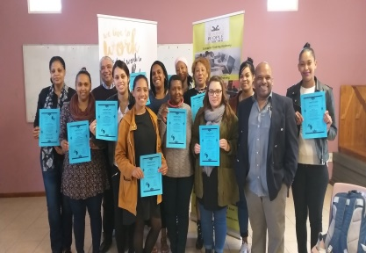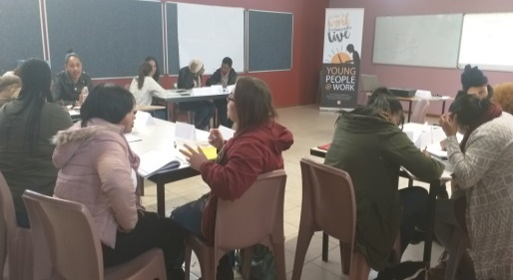

Master TTT hosted at Bishop Lavis library

MASTER TRAIN-THE-TRAINER
Whalemark Museum, Parow | 19-22 March 2018 | 14
Elsies River Library | 24-26 July 2018 | 19
Bishop Lavis Library | 2-4 Oct 2018 | 14
Bishop Lavis Library | 4-6 December 2018 | 11
Kimberley Rural Outreach | 18-20 December 2018 | 8
TOTAL |  | 66

Job Placement, referrals, job shadowing and tracking

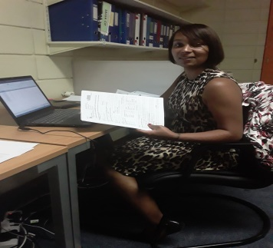

Participants referred and placed at various companies

Partnership building was an important strategic focus this year. In this regard we were able to expand our partnership base by accessing more partners and hence more placement opportunities. These partners include Ashley Kriel Skills Development Centre, I-College, Pillar5Group, George Driving School, Now Empowering Achievable Dreams (NEAD), community libraries and Cape Peninsula University of Technology.

We again have to report like last year, “…we have a tremendous challenge convincing participants on various courses to inform us when they access employment once they complete their training. Our placement and tracking results are therefore not reflective of the maximum number of placements. It only reflects information we have accessed based on our own tracking results, reports from partners and anecdotal evidence” We are also struggling with some partners to provide stats of placements timeously. These challenges affect our ability to properly assess the effectiveness of our strategies. We have recently started to request beneficiaries to copy us in emails when referrals are made. This has helped to track referrals but actual placement stats must come from the partner organisation.

We are confident that we exceeded our planned target for this programme with the new partners on board.

A summary of placements, referrals, job shadowing and income earned or savings made

Company/organisation | Nature of placements | Nr of placements
Cape Peninsula University of Technology (CT branch) | 6 month admin contract @ R6000 per month per person | 3
Pillar5Group | Business entrepreneurship course over 9 months– 126 referrals. Course is worth R15 000 pp. | 40
NEAD learners drivers training | 35 referrals made via Facebook for free training. Only R10 charge as admin fee. | 1 person completed based on current records
George Driving School | 65 referrals for this reporting period | 2 completed
Department of Education | Assisted 15 youth to register for matric online based on 31 Jan 2019 deadline | 15
Paralegal learnership | Paralegal training offered to unemployed youth. 1103 referrals registered via email. (Excluding those who missed the deadline on 30 November 2018) | No feedback received after numerous emails. Some candidates confirmed attending interviews but no placement on the actual course could be verified
Remax Real Estate | Intern placed in Jan 2018 made permanent in 2019 after completing a real estate learnership | 1
Harambee Youth Employment Accelerator | The following feedback was received: A Lead already exists for this contact number -1 1  Duplicate number in file – 7 7  Existing candidate. Candidate query loaded Successfully – 2 2  Lead loaded successfully – 38 (Above stats only for Oct – 2018/Feb 2019) 38 | 38
Dreamworker | 163 referrals made through our workshops for job placement. The organisation developed an online system called DreamXchange which makes tracking more difficult. | 27 placements confirmed
Gerli Clothing | 121 referrals made via our Facebook page for a clothing 6 month learnership paying a monthly stipend of R1100 per candidate . | 40 confirmed  1 machinist placed permanently
I-College | 87 candidates referred for various academic courses. One open day hosted at our training centre to recruit candidates  Study bursaries over 12 months are worth an average R40 000 pp. Only R600 registration fee is payable, | 23 - Confirmed in May 2018
Kolping SA | 20 referred by Linda Williams (hairdressing, chef assistant, home-based care, office admin) | 7 placed
Department of Labour | Hospitality training/Environmental Practice/Tourism | Placements in progress at the Western Cape Skills Training College. No data yet available.
Ashley Kriel Skills Development Centre | Call centre learnership offered through College of Cape Town – 120 referred via Facebook and whatsapp groups (exclude those who missed the deadline) Referrals were also made for a hairdressing course but no stats are forthcoming. | 10 completed training so far  1 placed as office intern
Fox and Woolf Web Developers | 39 referrals made | 2 people placed
Other companies | This include Reach Make It Academy, Foschini Group, ACSA, Home Improvements (Parow), Sun International, Oasis, Call Centre Agency, Dept of Labour, Bellville Traffic Dept, Woolworths, Cape College, Home Choice, Gulf Holdings, Chipboard City, Pick n Pay, City of Cape Town, Green Child, WNS Call Centre, Amingo Fisheries, Home Choice (24) | 24
Freedom SA | Adults 47/ juveniles 2. Males 28 /Females 21. Minor offences ranging from possession of drugs, petty theft, shoplifting, common assault, gender based violence, buying stolen goods, drunk driving. Major Offences 3 for presidential pardon application are robbery, murder, attempted murder. There were also 3 general enquires. 6 issues relating to SAPS criminal records centre capturing case as pending after been withdrawn. People who are able to start process now for clearing 15 with others having to wait for their 10 years to laps before starting process for clearing. | 15
Total | Referrals = 1969 | Placements = 248

Job shadowing
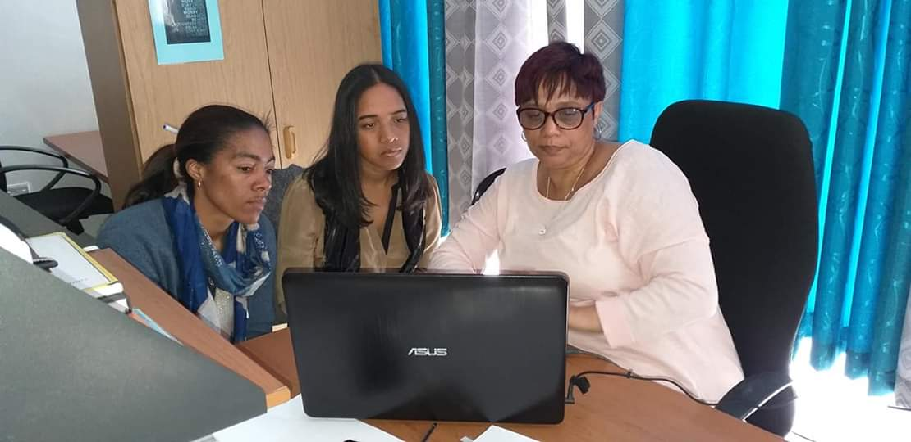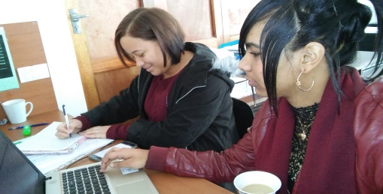
Staff member/partner | Organisation field | Nr
Linda Williams | Computer facilitation | 18
Shirley De Jongh | Bookkeeping, admin and computer facilitation | 14
Chante Rass | Office admin and banking | 7
Frank Julie | Organisational management | 9
Kuilsriver library | Admin support services | 1
Belhar library | Admin support services | 1
Adriaanse library | Admin support services | 1
Auto Pedigree | Car sales | 1
Total |  | 52 (25 in 2017)

Observations
Our decision last year to have staff getting more involved in job shadowing due to the limited opportunities, bore fruit this year as the numbers show. We got 3 community libraries on board with more who promised to join this programme. Our staff also committed themselves to job shadow at least 1 person per month or 10 per annum. This means we are able to provide at least 50 youth job shadowing opportunities.

Rural Outreach
This year we were invited by the Nelspoort Development Forum to host a life skills week in Nelspoort near Beaufort West. We also used the opportunity to facilitate a free fundraising workshop for youth based NPOs in Beaufort West.

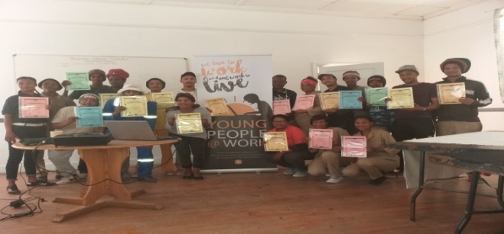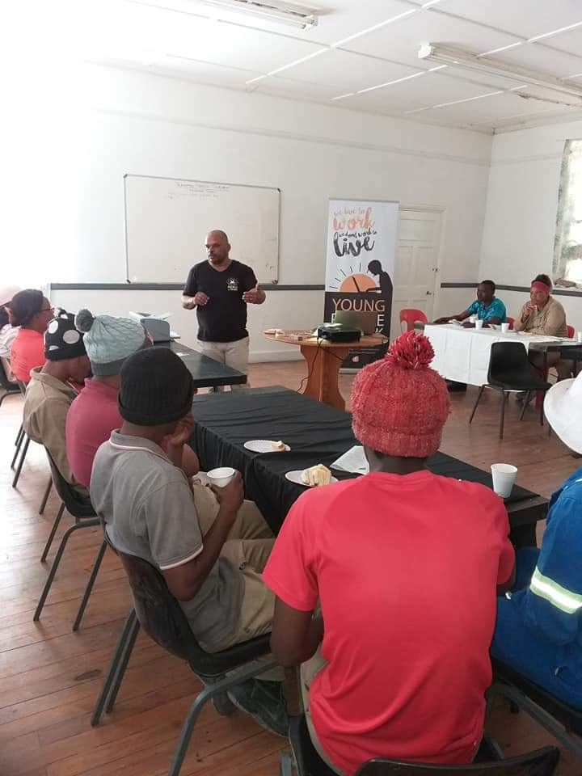

Life skills workshop in Nelspoort

Area | Activity
Nelspoort | 3 day life skills workshop from 2-3-4 July 2018 for 22 participants (35 in 2017)

Media and Marketing
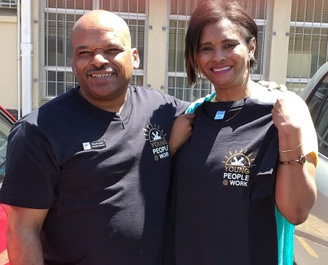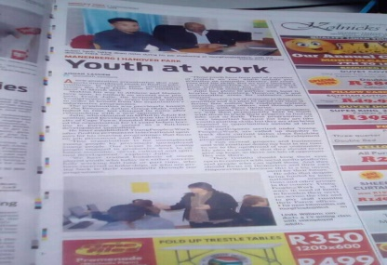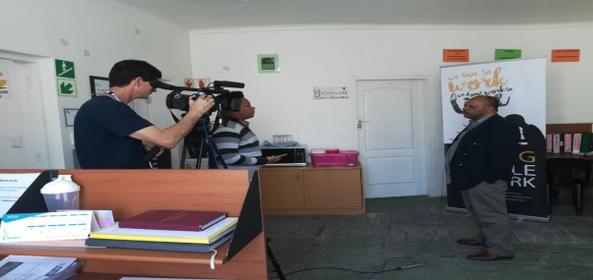

Our new t-shirt and YP@W in the local newspaper, Also our director being interviewed on national TV

Marketing medium | Quantity and focus | Area covered
Pamphlets and banners | New pamphlet, brochures and banners printed | Shared in workshops and compute classes
Murals | No murals added this year | n/a
Radio interviews | 2 interviews focusing on programmes for unemployed youth (Radio 786) | Cape Peninsula  Cape Peninsula
Electronic newsletter | 3 editions focusing on youth issues, programme developments and YP@W success stories | 2000 subscribers nationally; another 1000 subscribers added in 2018
Website | Continuous updating focusing on YP@W programmes | National and international
Facebook page | Daily updates on YP@W developments, success stories and job opportunities  The page has become more interactive to attract more followers. 3 competitions were launched and followers requested to share their visions and receiving advice and referrals. | Current and previous followers:  31 700 in Feb 2019  20 000 until Feb 2018  9862 followers – Feb 2016  4482 followers – 2015
Newspapers | Tygerburger, Peoples Post | Free articles covering our life skills training and free online job search training. Peoples Post covered a long profile of YP@W. with photos.
Block emails | Advertising our computer and life skills courses | Targeting mostly NPOs with youth volunteers
Whatsapp groups | Advertising our computer and life skills courses and advanced training | Targeting participants, ex-participants, walk-ins and youth empowerment week participants. Over 5000 contacts are reached via whatsapp group. This is fluctuating since contacts move in and out of groups
Word of mouth | Advertising our computer and life skills courses and job opportunities | Continuous and our main marketing medium based on participant surveys in workshops and application forms
Exhibition | Planned for November 2019 but had to postpone due to t-shirts and banners not yet ready. Now planned for June 2019 | Parow Centre (Mall) targeting unemployed youth from the northern suburbs
T-shirts | New t-shirts printed and sold. Cups with our logo are also being planned. | Sold to students and staff
Profile document | Reflective doc detailing the background and methodology of YP@W | Constantly updated and distributed to various stakeholders on request
ETV Extra | 7 minute interview with our director on the Jobs Summit | National broadcast reaching thousands. News clip shared in FB and viewed over 13 000 times.

Similar to last year our surveys conducted amongst our participants indicate that the most popular mediums to find out about YP@W are:
Facebook ,Whatsapp groups, newspaper (articles and adverts), Word of mouth, Pamphlets, Murals, Radio, Others.

Our marketing monitoring indicates that about 80% of all our participants accessed information about our programmes via Facebook. This trend started last year and is deepening as we doubled our following. We have stopped advertising in community newspapers, saving us at least R14 000. (4 adverts x 3500).

The huge increase in Facebook followers also led to an unintended consequence namely, a massive volume of messages via our inbox and comment facilities. We are currently estimating an average of 4 hours per day responding to messages and sharing relevant information.

Networking
Our current network partners are:

Partner | Investment made
RLabs Social Media Academy and Youth Café | Free scholarships for social media training
Harambee Youth Employment Accelerator | Referrals for jobs at mostly retail companies
Dreamworker | Referrals for jobs
Western Cape Youth Development Forum | Networking and exposure of our programmes in the bi-weekly newsletter
I-Can technology centre | Free bursaries for IT and social media training
Bellville Regional Library | Hosting of online job search training and life skills workshops
Delft, Adriaanse, Bishop Lavis, Bonteheuwel, Elsies River, Parow, Suidersee (Strand) Eikendal libraries (Kraaifontein), Whizz ICT (Blue Room), Grassroots (Athlone), Manenberg People’s Centre, Hanover Park library, Belhar library, Belhar Ext 13 library, Langa library, Gugulethu library, Adriaanse library, Delft South library, Bellville South library, Whalemark Museum | Hosting either the free online job search training and life skills workshops or both.
Kolping SA | Access to free bursaries for further training in office admin, catering (chef), home based care, ECD, hospitality, plumbing
Whalemark Museum (Parow) | Hosting 1 Master TTT and free online job search training as well one life skills course over 4 days.
I-College | Referrals to accredited one year courses
Gerli Clothing (Maitland) | Referrals to clothing learnership
Reach Make It | Referrals to welding and plumbing training
Pillar5Group | Provide placements for its business courses
George Driving School | Provide discounted driving lessons at R100 per hour instead of R180 which is the current rate
NEAD – Mitchells Plain | Providing free learner driver classes. Only an admin fee of R10 charged
Ashley Kriel Skills Development Centre | Referrals to training opportunities and learnerships
Department of Labour | Referrals to learnerships
Department of Social Development – Goodwood branch | Host a forum for youth employment service providers
Freedom SA | Provide free support with clearing criminal records that impede job hunting

Fund Development
The following is a summary of funding received and proposal submitted:

Donor | Amount requested | Status
Kerk in Acktie | R300 000 | 298 000 (due to fluctuation in exchange rate)
Department of Social Development | R250 000 | 131 300
Forza Foundation | R50 000 | 50 000 (R50 000 extra based on achievement of targets)
Total amount |  | 479 300 (612 915 in 2017)
Funding applied for
HCI Foundation | R50 000 | Declined
Grandwest CSI | R95 000 | Declined
African Women Development Fund | R300 000 | Declined
Hilden Charitable Fund – UK | R100 000 | Declined
Vodacom Foundation | R105 000 | No final feedback
Community Chest | R50 000 | No final feedback after step 1 completed despite numerous enquiries

Please note:
Kerk in Actie renewed their funding agreement for another 2 years until February 2020. This core funding is critical to cover our main overheads and programme expenses. The Department of Social Development (DSD) also renewed their funding agreement for another year. We are hopeful for another renewal in 2019. We were also visited by Gert Jan Pieterse from Holland who is the founder of the Forza Foundation to explore a funding partnership which eventually resulted in funding of R50 000. Another R50 000 is subject our targets being achieved. During a recent visit we were informed that funding will continue in 2019.

Please note: The National Lottery Commission funding of R107 000 started in September 2017 and ended October 2018 which means that 80% of their funding was utilised from January – October 2018. We did not include their funding in our total since the funding was received in 2017. We hope to reapply in 2019.

Own income generation
Income streams | Amount
6 week computer training fees, computer manuals – computer fees were increased from R995 t0 R1100 for the unemployed and R1200 to R1400 for employed. Include 8 day computer sessions. | 110 501 (110 665 in 2017)
4 days online job search training (include CVs and certificates) this fee was increased from R10 to R15 per copy | 26 459 (15 852 in 2017)
Workshop fees, manuals, CV typing, printing | 18 846 (35 410 in 2017)
Individual donations (Facebook appeals and monthly debit orders) | 6150 (17 871.89 in 2017)
Volunteer and board contributions (for daily tea and coffees) | 1220 (660 in 2017)
T-shirts | 200
Insurance refund for two desktop computers | 8 140
Interest from notice account | 23 313.15 (17 910 in 2017)
Subtotal | 194 829.15 (207 868.89 in 2017)
Total financial income | 674 129.15 (820 783.89 in 2017)
Material donations (and donations in kind) and estimated value
Choose Life Businesses – outsourced (we only pay a donation of R350 p.m.) | Bookkeeping and accounting services @ a saving of 6000 p.m. x 12 = 72 000
Whalemark Museum | Saving on monthly rental @ 5000 p.m. x 12 = 60 000 (2 offices and free access to a hall for training space)
Saving on director’s salary (market rate is 25 000 p.m. but current rate is 7000 p.m.) | Saving made: 18 000 x 12 = 216 000
Access to community library halls for life skills training, online job search training, train the trainer and Community Investment Prog classes | Workshops x 500 per day x 201 days = 100 500
Lana Maart – professional HR officer at City of Cape Town | Free 90 minute session on job seeking skills valued at R2000
Freda Camphor – Assistant Director at Department of Labour | 2 free 2 hour session on Labour Rights in the Workplace valued at R4000
Hoosain Adam – Holistic Financial Services | Facilitated a workshop valued at R3000
Preparing annual financial statements | Saving R4000 based on a discount by our professional accountant
Staff salaries | We saved two staff salaries by not appointing new staff in March 2018 until February 2019 x R8 000 p.m. = R96 000
Cartridges donated | Cartridge Warehouse spouse 3 cartridges to the value of R2000 in total.
Subtotal | 555 500.00 (346 000 in 2017)
Total amount of own income generated including savings made | 750 329.15 + funding received of 479 300 = 1 229 629.15 (1 166 783.89 in 2017)

Please note:
- Due to the depressing economic climate, we kept our target for own income the same as last year at R200 000 – R220 000.
- The reduction in workshop fees is a result of fewer NPO workers who pay when attending especially from Ithemba Labantu.
- Our 6 week computer course income was again under pressure even though we charge much less than the market rate. We are still constrained to offer evening classes due to a lack of transport. Saturday classes for employed people have mitigated this loss. We have also increased our fee for the unemployed with R100 and R200 for the employed.
- Fees for CVs and certificates were increased with R5 each. During the Community Information Sessions (Open Days) we did not charge for CVs. No admin fees were received this year for placements.
- Income from individuals continues to be under pressure. This is due to the economic pressure.
- Income generated through interests on our savings at Nedbank increased due to the higher interest rate as well as prudent financial planning and spending by management.
- We continued to make substantial savings since the relocation of our office to Parow in 2018. We made a saving of R5000 per month resulting in savings of R60 000.
- We also made substantial savings by not employing two new staff for 2018. This saved us at least R96 000 based on a R8 000 per month saving.
- The savings generated assisted us in boosting our financial reserves to make us less vulnerable for a funding gap or an unexpected donor exit. In February 2019 we had the equivalent of 6 month reserve based on a maximum monthly spend of R50 000. Our objective is to increase this to 12 months.
- Our professional accountant has provided us with a substantial discount of R4000 to prepare our annual financial statements. Our monthly financial reports are done at a cost of R350 only saving us the monthly part-time salary of R6000 for a bookkeeper.
- We developed two new income streams namely producing t-shirts to market the organisation selling to our students and receiving a commission from George Driving School from referrals for drivers licence training.
- As part of keeping our overheads low we recently decided to cancel all refreshments during workshops as well as plastic sleeves. The savings generated will be put into a transport fund to assist job shadowing participants with transport donations. We hope to raise at least R24 000 this year with this saving.
- We continue to benefit from our partnerships with the community libraries with access to their computers, Wifi and halls which are saving us thousands of rand.
Finance
The following developments transpired:
- We have eventually received our PBO and 18 certificates from SARS after 3 years of waiting. This allows us to now target corporate donors more vigorously since this is a requirement for many.
- Our Unemployment Insurance Fund was also finalised recently after more than 3 years of struggling with the relevant authorities.
- Financial projections are still done on an annual and quarterly basis and strictly monitored on a monthly basis. A copy of our annual projection is shared with the board to hold management accountable.
- We managed to claim insurance for 2 desktop computers from Santam. This allowed us to purchase 5 new laptops to respond to the huge intake at our online job search training.

Internal auditing:
Similar to last year, our director undertook two internal auditing exercises. This included scrutinising various programme documents such as attendance registers, course framework, payment agreements by students, receipt books, cheque requisitions, minutes of meetings, etc. Staff members were afterwards consulted and recommendations made for improvement of systems and procedures. Concerns raised during last year’s process, were addressed successfully. The capturing of strategic information also improved making decision making monitoring and evaluation and hence decision making more effective.

Strategic assessments:
Two such workshops were held in July 2018 and December 2018 to assess our plans as agreed upon in January 2018. Copies of the reports and recommendations for improvement were submitted to the board.

Office administration
Our office administration has been very efficient compared to previous years. This is partly due to the training of office staff and better equipment. We acquired faster laptops after complaints from staff. Record keeping is also very efficient as highlighted during our internal audits.

Transport: Our staff, that depend on public transport experience huge challenges due to the unpredictable nature of our public transport system. Increasingly they are forced to make use of Uber which is more costly but more reliable. We are monitoring the problem and decided recently to create a budget for transport emergencies. This will also cater for students who lack transport fees to access job shadowing opportunities.

Board developments
The board met 3 times this year. No new members joined the board. Portfolios remained the same as last year. The planned board and staff social gathering never materialised. The director and chairperson met informally during two breakfast meetings to debrief on current developments in the organisation.

Staff development
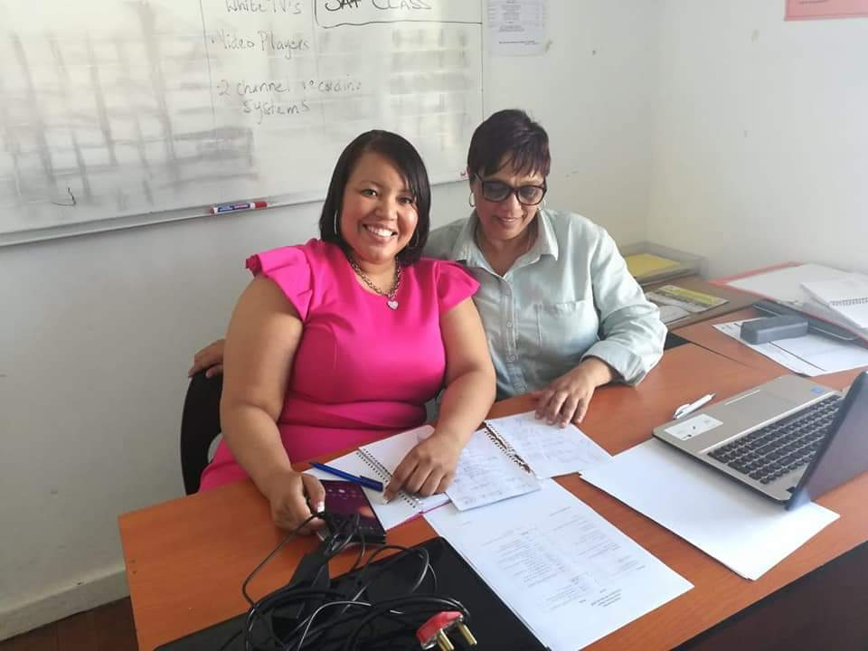

Cheryl-Lynn Freeman mentoring Shirley De Jongh/Staff members on a visit to Robben Island

Staff members and volunteers were exposed to the following training:
Activity | Facilitator
Intermediate and advanced Ms Word and Excel (still in progress) | Shirley De Jongh
Continuous mentoring of Chante Rass in office admin and reporting to DSD | Shirley De Jongh
Frank Julie attended PHD classes at Stellenbosch University and busy currently with his research proposal on effective youth employment strategies and the role of formal and informal learning. | Frank Julie
Shirley De Jongh | Continuous mentoring by Frank Julie in financial planning, financial projections
Shirley De Jongh | Coaching by Frank Julie in work plan development and reporting
Shirley De Jongh | Continuous mentoring in donor management and reporting
Shirley De Jongh | Training in SAGE accounting by Cheryl-Lynn Freeman from NPO Accountant
Shirley De Jongh, Frank Julie, Linda Willaims, Chante Rass | Evaluation of our Online Job Search Programme by Gerswhin Ederies from Stellenbosch University and guiding us through our theory of change.
Staff evaluations happened twice in July and December to assess staff performance | Frank Julie
Computer trainer evaluations of Linda Williams and Shirley De Jongh | Frank Julie
Staff outing and teambuilding to Robben Island on 12 December 2018 | Frank Julie
Staff responsibilities
Frank Julie – Executive Director | Org management, external fundraising, training of trainers, marketing, board development, staff evaluations, networking, transport, banking, shopping, financial planning, reporting, strategic planning, life skills facilitation, rural outreach
Shirley De Jongh | Bookkeeping, job placements and tracking, online and 6 week computer course facilitation, office admin facilitation, admin and workshop bookings, online and computer class bookings, minute secretary for board meetings, workshop coordination and logistics
Linda Williams | Online computer facilitator, workshop and admin assistant, (6 week course facilitation in progress)
Chante Rass | Admin assistant (was trained by Shirley De Jongh)

Feedback from participants
"Growing up was not easy, to remain positive againts all odds was also not easy. Deep down inside of me was a yearning for sustainable change. I studied for social auxiliary work and was waiting long to get my results. I applied for vacancies, but nobody ever responded. I was feeling very hopeless. I contacted Linda Williams, my facilitator from YoungPeople@Work. She motivated me to apply for vacancies as well as online. Also to remain positive against all odds.
I want to thank Frank Julie and the entire staff for being a portal of change in our marginalised communities.You light up many lives to bring change. Thank you for the free computer trainings in our communities and the motivation and guidance you give to make an impact in our lives.You do great work. Each one Teach one.” (Senead Booysen)
“I just want to say Thank You to Young People @ Work for creating this opportunity for us and for seeing our potential. A big thank you to Frank Julie for taking time out of his schedule to teach and train us. It was indeed worth the time and effort. God bless you in your work in the future ahead.” (Shane Prins)

“I want to take this opportunity to thank all at YP@W for the amazing work you do. When I left school 17years back not finishing my matric I had no idea that there were places like YP@W that encourages and motivate people like myself that we can empower and educate ourselves through the help of them. YP@W gave me a new chance in life only what I could dream of. Their courses and workshops are truly amazing and they go the extra mile for us to understand without putting pressure on us but they encourage us and motivate us that we can do it! So yet again to all I THANK YOU for giving me and all who attend your programs a second chance in life....GOD BLESS YOU ALL”. (Vanessa Daniels)

Other developments

Risk factors
- Funding: We are in the process of cultivating new donors in view of the donor contracts coming to an end in February 2020. We are targeting two donors in this regard.
- Staff retention: We decided to recruit two new staff to mitigate the loss of two staff last year in February. We are very close (75%) to paying our staff competitive salaries unlike previously.
- As stated in the previous report, the part-time director needs proper remuneration to ensure a stronger focus on YP@W management) Fulltime work results have to be delivered on a part-time basis currently. His current remuneration is about 25% of a market related salary.

Strategic focus areas for 2019
- Further expand the external funding base and further deepen our own income base. Review computer current computer fees and launch new income streams.
- Increase the level of placements and referrals by developing more partnerships to maximise impact.
- Improve documentation of placements and referrals through our partners.

Music Academy for Rural Youth (MARY) and Master Fundraising Network (MFN)
Despite the increased work pressure, the organisation provided administrative support and mentoring for MARY and the Master Fundraising Network (both membership based organisations) which were initiated and incubated by our director to serve rural youth and professional fundraisers/directors/programme managers respectively. These organisations are registered with their own boards and programmes and have a strong youth development focus.

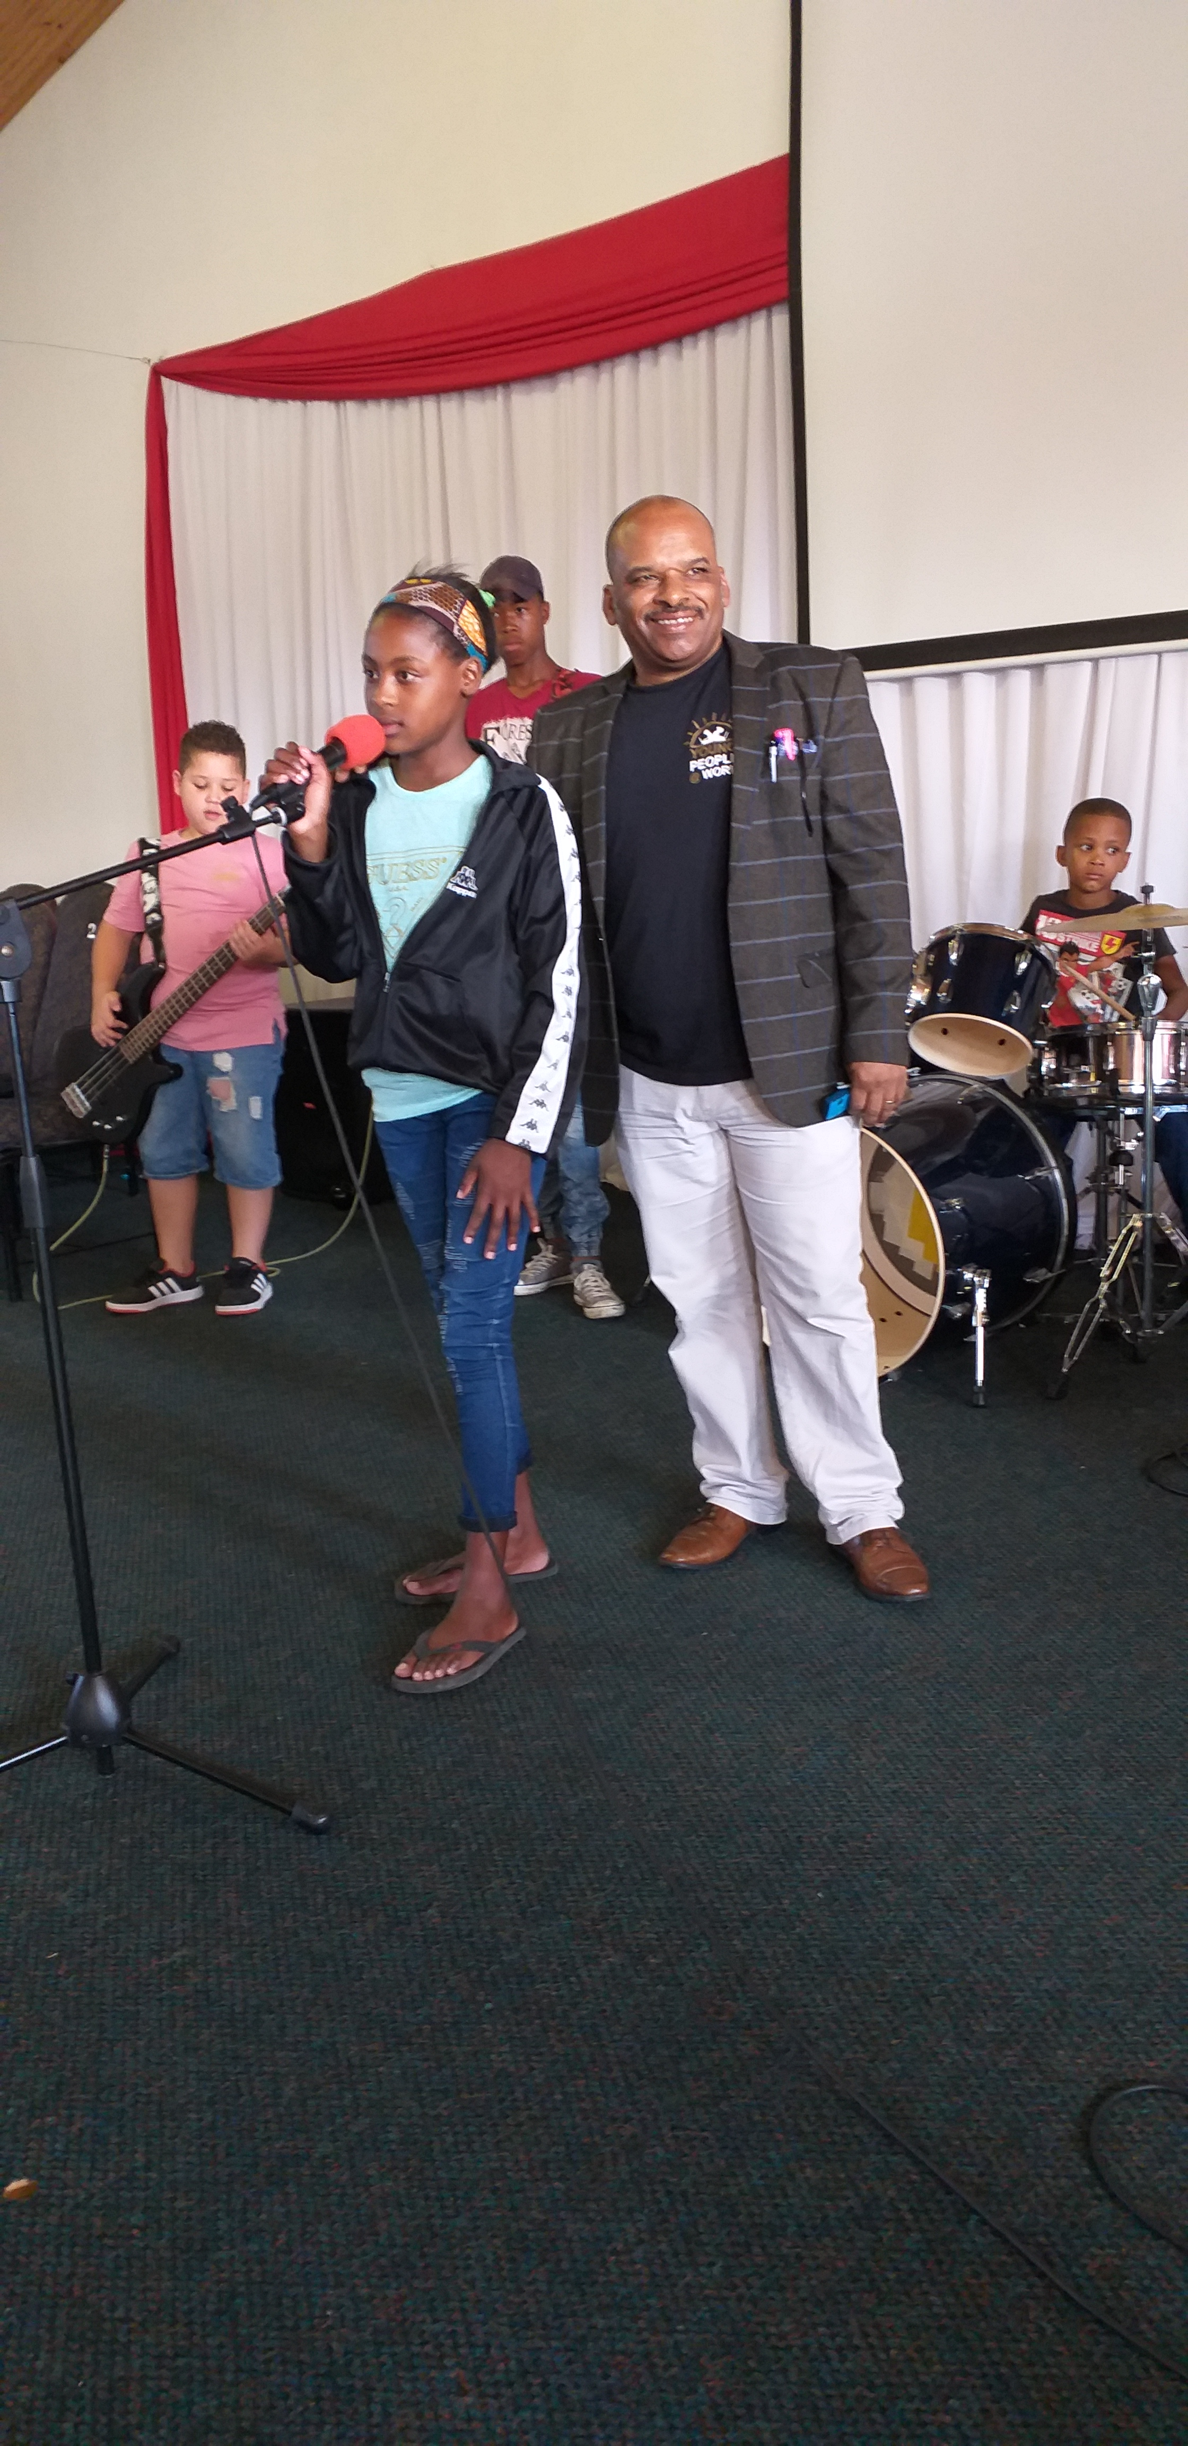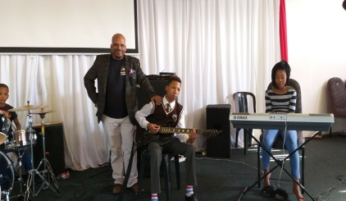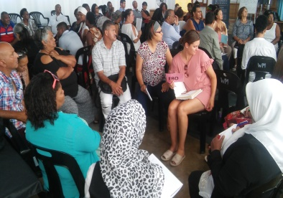

MARY trainees / MFN workshop in progress
Northern Cape branch
This branch based in Kimberley hosted their first computer literacy training in February this year after a number of obstacles had to be overcome. They lack funding to appoint a fulltime coordinator resulting in sporadic activity. A train the trainer was hosted by our director in December 2018 and a life skill week in July. 6 laptops were acquired to assist with computer literacy training. A serious obstacle is the lack of a venue to continue with their training. Community libraries are not as accessible as in Cape Town.

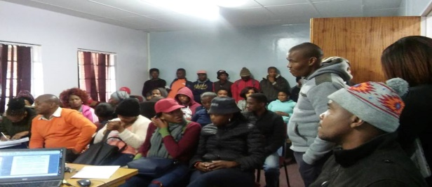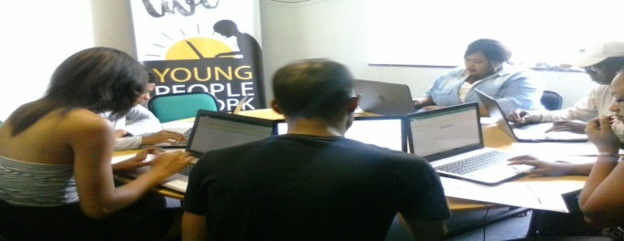
A life skills workshop in Kimberley and the local volunteers busy with computer literacy training

Summary of investment in our beneficiaries in Rand terms:
Programme/activity | Quantity and average market rate | Average Investment
6 week computer course | 110 participants x 3000 pp = | 330 000
Online job search training | 1123 participants x 1000 pp = | 1 123 000
Community Investment Programme | 48 participants x 1000 pp = | 48 000
Life skills training (CIS/Youth Weeks) | 1321 participants x 350 pp = | 462 350
Master Train the Trainer | 66 participants x 1500 pp = | 99 000
Rural Outreach Programme | 22 participants x 3 days x 350 pp = | 23 100
Total investment through skills training |  | 2 085 450

Conclusion and expression of gratitude
Clearly, this has been our best year in many respects. With a skeleton staff we were able to reach thousands of unemployed youth and helped to provide hope and turn around lives. From 5 libraries and communities targeted in 2015 we have now expanded to 18 libraries and communities to access our services. Our reach through Facebook as our primary marketing tool has literally exploded due to a concentrated focus to build this tool. This has led to a demand for our services. Fortunately we were able to meet the demand due to our flexibility and determination to make a difference.

I wish to thank our board and staff for their support in living the vision and mission of the organisation. Without them nothing will be possible. Despite the challenges of working and travelling in dangerous environments coupled with an uncertain and unpredictable funding future, we still delivered the best we could give with scant resources. Again we thank our donors for their generous support, both financial and material, in support of our mission to empower unemployed youth to access decent employment! Without your continued support our work will only remain a wishful dream!

We thank you
Frank Julie
Executive Director
14 April 2019

More photos of various programmes and events:

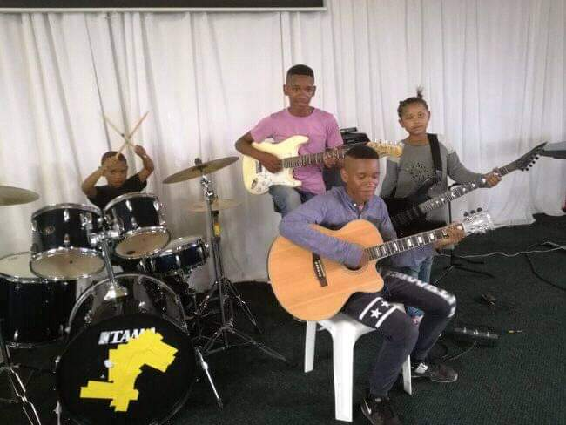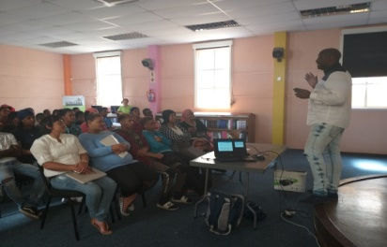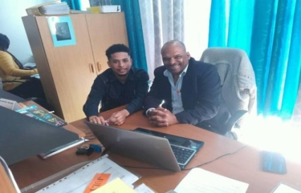

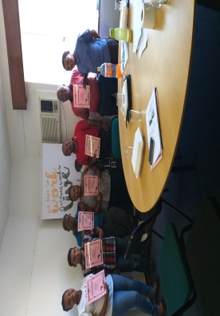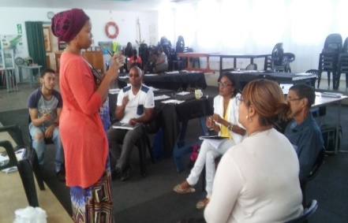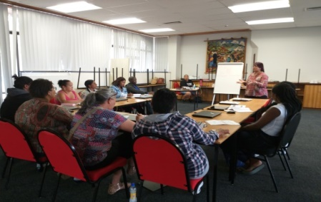

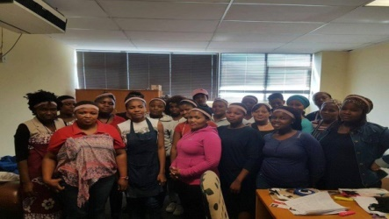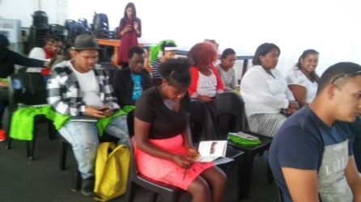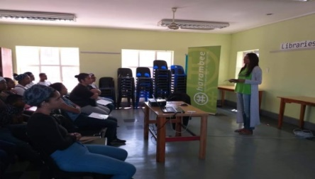

From left to right: Music Academy for Rural Youth members in training, Cole Davids from Pillar5Group shares employment and training opportunities, Ruben Sauls job shadowing Frank Julie, Volunteers in Kimberley trained as trainers, A TTT session in progress at our centre in Parow, An online job search training session in progress, Gerli Clothing placements, I-College Open Day at our centre, Zayb Moses from I-College sharing academic courses available at a life skills workshop in Hanover Park.

