YoungPeople@Work

Network Update

Because you have the right to know!

March 2013, No 1

Tel: 021 911 5444, Cell 078 812 4603, Email: youngpeople.za@gmail.com

Website: www.youngpeopleatwork.weebly.com

Why this update?
Welcome all our partners to the first issue of our quarterly network update. With so much happening in YoungPeople@Work we need something to keep all of you updated. This update will be circulated every 3 months in the spirit of accountability and transparency. Your feedback, comments and questions are welcomed
Donation from CCFM Radio
So the good news just does not stop! CCFM Radio just sponsored YP@W with R5000 towards our running costs. And this is not all. After we met with them (Frank, Shirley, Victoria and Steven) they agreed to allow us some more airtime to advertise our Youth Empowerment Weeks. They even offered to YP@W their training space to do free workshops.
Time to pause, reflect and plan ahead!
We will soon organise a day of reflection for all members to check how far we came since 27 March 2012 as well as reviewing our strategic plan of 1 December 2012. Watch this space! It is time to learn some lessons!
Youth Empowerment Week - Kraaifontein
Our Kraaifontein Week was a huge success. Thanks to our board member, Ronald Wesso, who convinced Surplus People’s Project (SPP) to partner with us and who covered the catering and printing costs of the manuals. Without any funding we were still able to pull off this project with very good results. Thanks to Shirley, Erica, Victoria and Steven who did all the spadework, going to Kraaifontein and handing out pamphlets at spaza shops, libraries, businesses, clinic, etc. And thanks to Ronald also for coordinating from his side and taking responsibility to assist the new volunteers in that group. A big thanks to Shirley, our office administrator, for capturing the CVs of the participants subsequently. The feedback was very encouraging and we cannot wait to WOW our fellow unemployed youth in Bonteheuwel who is next from 16-18 April. And then its Elsies River, Delft and Mitchells Plain!! Funding or no funding, the work goes on! And then we on our way to Heidelberg, 22-23-24 March, our first rural outreach organised by Debbie Willemse supported by Heidi Schutter (also a board member) in that community.
Please invite your friends to like our Facebook Page and get regular updates!!
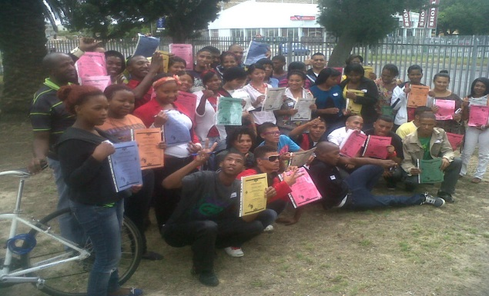
Above: Kraaifontein Youth Empowerment Week participants showing off their certificates!
RLabs Social Media Academy Training
So it all started on 2 February 2013 with an orientation. Our volunteers and staff members started their social media training at RLabs Social Media Academy in Athlone. And are they not enjoying it!! Great stuff!! Shirley, Victoria, Erica, Caroline are attending the same classes on a Saturday with Jessica and Shaamilah attending together. Tyrone and Jolene are attending classes on a Wednesday. YP@W is sponsoring their transport costs. We already heard how our members have to assist in the classes! They are making us proud!
Computer training centre –we are almost there!
So, we love it when a plan comes together! The computer training centre we planned last year will be ready very soon. Thanks to a donation of 25 computers sponsored by Metropolitan Health Group and free training and admin space from Adonia Life Ministry in Bishop Lavis we will soon launch. Software is in the process of being uploaded and will be completed soon. We hope to start using the centre in March and launch publicly with our Day of Gratitude on 20 April 2013.
Capacity Employment Agency
We are currently in negotiations with Capacity Employment Agency to employ trainees we will refer to them. We are exploring a partnership that will be mutually beneficial, also financially. Once details have been finalized we will report. We hope this partnership will allow more of our trainees to secure employment. Watch this space!
CV Bank
Our office administrator, Shirley, has been hard at work uploading CVs into our CV Bank over the past few weeks! Please check the CV Bank to see if your CV is uploaded. If not, contact Shirley. This means that for many participants from our workshops, their CVs are literally a click away! How much more easier can it be to secure an interview now?
Day of Gratitude
YP@W will be one year old soon (end of March) and we decided it’s time to say thank you. On Saturday 20 April 2013 from 1.00 p.m. – 4.00 p.m. we will be hosting a Day of Gratitude at the Adonia Life Ministry. We are planning to host about 60-70 guests who have made a contribution to our growth so far. Shirley will prepare a 3-course meal as only she can! Donations are welcome!
Board meeting on 23 February 2013
Our first board meeting took place. The board had a lot to discuss after we last met on 5 December 2013. Two issues that stand out are the idea of starting a Job Seekers Union for unemployed youth and our own employment agency as a cooperative to generate income. Both initiatives will be discussed at a special gathering on Saturday 13 April 2013 at the home of the chairperson from 1.00 p.m. – 4.00 p.m. followed by a social gathering for members. Don’t miss this one! There will be some real fun in the sun! Ask Shirley…
Radio 786 free slots
The radio gave us 6 slots to host from 12 February 2013 to end of May. We are on air every alternate Tuesday evening between 8.00 p.m. – 9.00 p.m. So far we hosted 2 slots very successfully with another 4 to follow. Freda Camphor and our own chairperson were the first two guests. We also plan to invite Career Planet, Dreamworker and Jobstart. Check out 100.4 FM again on 12 March 2013.
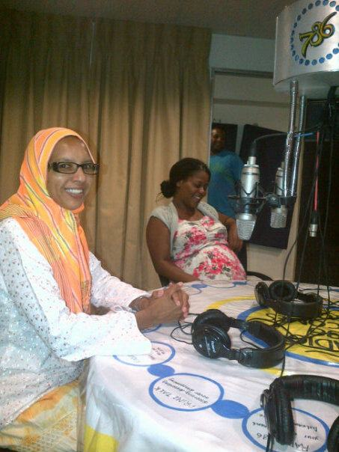
Above: Shaamilah and Marileze at Radio 786talking about interview skills
Job Mirroring (Shadowing)
Another successful Job Mirroring Week was held in partnership with the Department of Labour from 18-21 February 2013. Thanks to Steven, Caroline, Jade and Cheryldene for making us proud! The feedback was very positive and they even had a debriefing with the head of the Labour Centre on their final day! We are in the process of organizing another group soon. In the meantime Erica is having a ball of a time at the Wheat Trust with Soraya Mentoor, the executive director. She is now working with Soraya every Thursday assisting with filing. Erica even went on a march against rape to parliament with them!
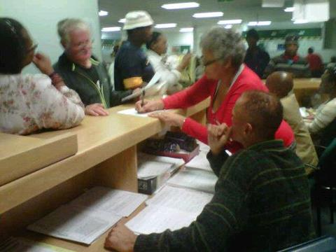
Above: Steven and Caroline take over at Department of Labour in Bellville!!
Cape Town TV membership
We have recently joined Cape Town TV as a member and will now enjoy all the benefits of membership. This will include free advertising and access to Open Studio where we can host our own interview. CTV also offers internships to youth with a passion for media. Imraahm Mukkadum, the marketing and sales manager recently spoke at workshop which I facilitated in Bellville. This partnership is growing stronger by the day!
Tracking form to measure impact
A tracking form has been designed for all our participants who secured employment since last year to check who is working where, what they do and who benefits from their employment. In this way we will be able to measure the direct and indirect we made in people’s lives.
Interesting websites:
Please visit www.theclothingbank.org.za where you can request a donation of clothing as well as read how this NPO empowers unemployed women with business skills and starting their own clothing distribution centres.
www.rlabs.org – read more about their free scholarships provided to unemployed youth and women and the various social media courses on offer! New intake starts in July 2013! Do not delay!
Please take note of these upcoming dates!!
9-12 April 2013. Train-the-Trainer course
26 April 2013: Kareoke fundraiser being organized by Shirley, Victoria and Erica in Belhar.
23-25 April 2013: Web design training: at Bishop Lavis library. Free for YP@W members!! Non-members: R500 pp.
Please visit our website for more dates of more workshops, Youth Empowerment Weeks, rural outreach and Media Week at www.youngpeopleatwork.weebly.com
Our contact details: Frank Julie – Tel: 021 911 5444 or Cell: 078 812 4603; Shirley De Jongh – Tel: 021 695 5895 or Cell: 074 350 8582; Victoria – Cell: 073 721 0807
We Live to Work, We don’t Work to Live!!

