YoungPeople@Work
We live to work, We don’t work to live!!
(Reg nr: NPC - 2012/210099/08)
YoungPeople@Work (YPW) is a new generation organization for young people by young people working with unemployed youth in the Western Cape with its base in Bishop Lavis. It follows in the proud traditions of the Resource Action Group (RAG) launched in 1993 and that closed down in 2006 due to a lack of funding.

Our vision is about young people engaged in productive work to enhance economic, social, cultural and spiritual development. We regard working on oneself as the most productive work! In YPW youth are not just recipients of predesigned programmes, but active participants in the design themselves. We regard youth as assets not liabilities. We believe they have inherent talents, strengths and positive energy that must be harnessed to facilitate their holistic development to their fullest potential.

Our programmes:
Computer and Life Skills Academy

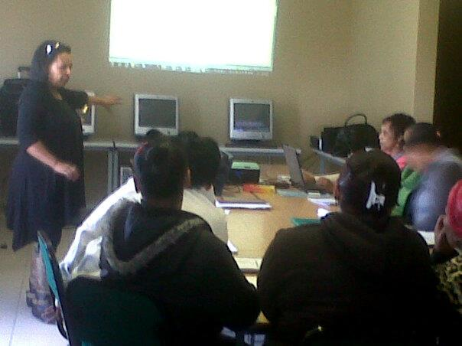

Finding a job is important, but finding and working on yourself is your most important job!!

Our Academy offers the following 3 month course:
Introduction to computers - Computer based typing - MS Word, MS Excel - MS PowerPoint - MS Access – Internet/email

Plus free workshops in:
Personal development and leadership - Professional job seeking and networking skills - Effective customer relations - Effective money management – Project management
You also get free:
CVs uploaded into our CV Bank - Computer practising classes; Email/Facebook account and follow up support! Small classes with individual attention - Affordable rates with monthly instalments and certificates – Flexible class times – Computer manuals
We help our students find work!!
Classes on Mondays/Wednesdays or Tuesdays/Thursdays
Course duration: 3 months - Fee: R990 per course (unemployed) R1590 per course (employed)
Deposit: R100 (unemployed) R250 (employed) Course starts on
Class times: 9.00 a.m. – 11.30 a.m./12.00 p.m. – 2.30 p.m. / 3.00 p.m. – 5.30 p.m. / 6.00 p.m. – 8.30 p.m.
We also offer training in:
Basic office administration and bookkeeping

Youth Empowerment Week
During this intervention we reach unemployed youth in their respective communities where we arrange a 3-day workshop at the local library. Various stakeholders are involved and consulted. We focus on professional job seeking skills, personal development and life management and the last day our strategic partners share various job and training opportunities. CVs are designed and uploaded into our CV Bank on our website. Participants are also interviewed by our strategic partners and their details captured on their databases for follow up purposes. Volunteers are recruited and encouraged to form a local YPW club for after care and follow up support. Clubs already operate in Bishop Lavis, Kraaifontein, Bonteheuwel and Elsies River and more are planned in other communities. These clubs also form networks of support and solidarity for unemployed youth and keep them engaged in continuous learning, volunteering in their community and acquiring new skills.

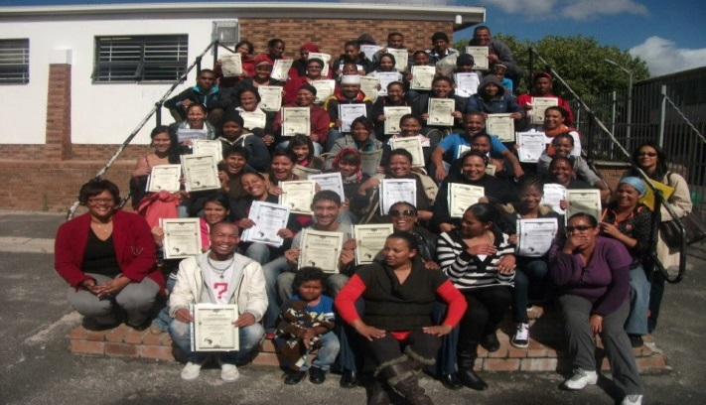

Every library a learning centre, every table a desk!
We partner with community libraries where YPW volunteers provide free basic computer training using the Smart Cape computer system. Here the objective is 100% computer literacy amongst unemployed youth, allowing them to do basic job research and complete their own CVs for uploading into our CV Bank.

Our Advanced Leader-to-Leader Course
This is a 3-month course designed primarily for leaders working to support the unemployed and NPO leaders in general. This course focuses on leadership and management, marketing and media, life skills, strategic planning, professional fundraising and proposal writing, project management, effective governance, monitoring and evaluation, train-the-trainer skills and field visits. Integrated into this course are practical needs based assessments that lead to concrete outcomes for participants. Specialists facilitators are recruited to share their skills and experiences.

Our SMS Notification System
As part of our after care and follow up we have a SMS Notification System where we continuously inform unemployed youth on our database about potential training and job opportunities. They are also encouraged and supported to join our Facebook page where jobs are continuously posted.

Job mirroring (shadowing)
Our members are placed with various professionals at various institutions to acquire experience of the world of work. 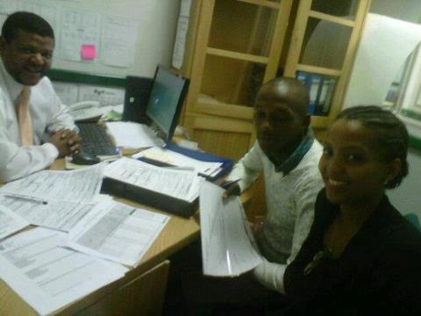

Effective use of social media
We also use social media like Facebook and to connect unemployed youth with potential jobs. Continuous research about jobs are done and sourced and then posted on our Facebook page on a daily basis. We assist our trainees to connect to our Facebook page using their cellphone. Participants to our workshops are supported to open up their own email accounts.

CV Bank
The CVs of participants to our workshops are uploaded into our CV Bank on our website. This innovative approach allows potential employers and employment agencies to easily connect with potential candidates for employment.

Rural Outreach and Networking
We share our expertise with rural unemployed youth and provide bursaries to access our training. We provide continuous support and encourage them to organise
themselves to reach more unemployed youth.

Youth Development Support Unit
We provide support to young people already involved with community projects or their own businesses. This include marketing, governance, fundraising, strategic planning, programme development, networking and administrative support.

Our network partners:
We network with the following organizations to add mutual value to our work with unemployed youth:
Dreamworker (www.dreamworker.org.za)
Jobstart (www.jobstart.org.za)
Career Planet (www.careerplanet.co.za)
Cape Town Activa (www.capetownactiva.com)
University of the Western Cape (UWC) (www.uwc.ac.za)
RLabs Social Media Academy (www.rlabs.org)
Department of Labour (www.labour.gov.za)
Adonia Life (www.adonialife.webs.com)

Marketing and media
Our members are trained in marketing and media and then employ these skills within the organization. This includes print and electronic/social media. We have a well-designed marketing strategy to connect with unemployed youth via Facebook, our website, pamphleteering campaigns in communities, newspapers, Cape Town TV, block emails, newsletters, brochures, strategically placed murals, presentations, site visits, block SMS’s, etc.
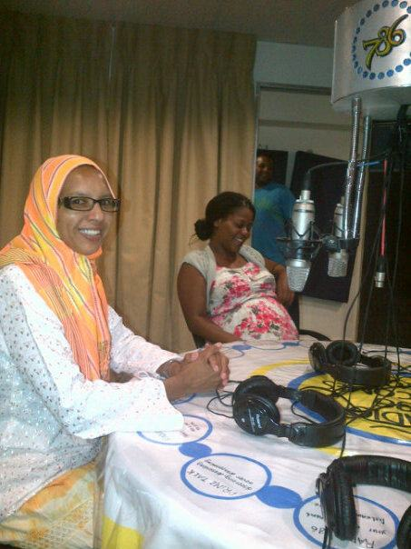
Some of our supporters:
Community libraries, CCFM Radio, Radio 786, Tygerburger newspaper, Metropolitan Health Group, SA Foundation (Holland)

If you think education is expensive, try ignorance!

South Africa Foundation (Netherlands)
What some of our participants had to say:
“I don't know if my wording is going to be right. You would not know what fantastic news I have. I have received a call today that i'm starting on Monday at The Foschini Group (TFG) do you know because I did my training through you. I have aced my assessment 96% for vocal and my typing. Thank you for making a difference and changing lives. Now I am ready for the new challeges. Thank you Frank Julie now 2012 is ending well. Keep on what you doing by making a difference.” Nazeema Mohammed

"Hey Frank I really need to thank you for a job well done. YoungPeolpe@Work you have given me a new way of looking at things. When I attended your workshop I was shy an had no confidence I thought I was just gona have to just work at a factory and didn't know I have so much opportunities never thought I would be sitting behind my own desk at The Foschini Group head office in the HR Department. YPW you empower youth and change their mindsets. I am so honoured 2 be a part of this family and I know you gonna touch so many hearts this year!!” Jessica Pietersen

“I had a great time here ever since the day I came. I got a lot of information and even the people were patient to speak and listen to us. So Frank and his team have done it all for us, because they were excellent. Thank you so much!!” Khanya Mabunzana

Our board of directors
Marileze Williams (Chairperson), Frank Julie (Vice-chairperson)
Estelle Hendricks (Treasurer), Heidi Schutter (Secretary)
Ronald Wesso (Assistant Secretary)

Forward to lifelong learning!
Forward to a new vision!

Contact us here:
YoungPeople@Work
Corner of Sky/Sun Road, Bishop Lavis, 7490
Telephone/SMS: 021 823 7837
Fax: 021 911 5444
Cell: 074 350 8582
Email: youngpeople.za@gmail.com
Website: www.youngpeopleatwork.weebly.com
Facebook: https://www.facebook.com/YoungPeopleWork

