YoungPeople@Work

Quarterly Update

April - June 2013, No 2 –

Because you have the right to know!

Tel: 021 823 7837, Cell 074 350 8582, Email: youngpeople.za@gmail.com

Website: www.youngpeopleatwork.weebly.com

Operation Hope computer and life skills course kicks off!
And so, eventually, after so much training of trainers and hard work to prepare the computer training centre, we launched our 3 month computer and life skills course on 19 June 2013. Well done to all those who completed their Train-the-Trainer course. Lots of work still lies ahead. Already Shirley and Vicky have their own classes, with Estelle doing training with our students from Heidelberg. We started to intensify our marketing through the schools. Community libraries will also be targeted.
Youth Empowerment Weeks – putting Bonteheuwel, Elsies River and Chatsworth/Riverlands on the map!
Successful Youth Empowerment Weeks were held in the above communities during April and June. In all the workshops an average of 60 unemployed youth attended. Volunteers decided to serve their communities by starting YPW clubs to reach more unemployed youth. Already volunteers from Bonteheuwel and Elsies River started their free computer training at the Computer and Life Skills Academy. They are trained by Victoria Petersen.
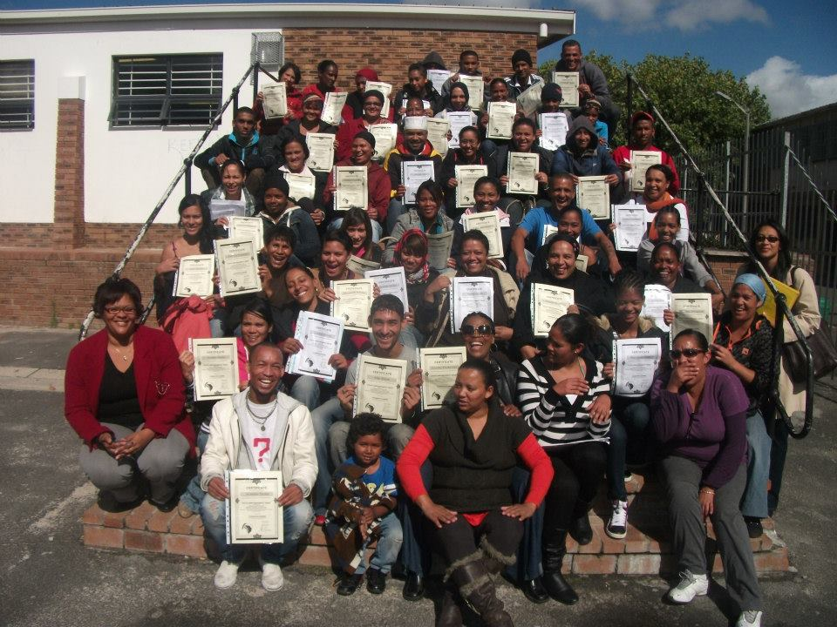
Library based online job search training
As part of a new offering to the unemployed we will launch the above programme in July. Bishop Lavis and Adriaanse libraries will be pilot sites before we roll out to other libraries. YPW volunteers Erica Laban and Lorne Isaacs will be deployed at Bishop Lavis library and Gadijah Eckleton and Juanick Snyman will be based at Adriaanse library. Charmaine Jansen will assist. Marketing already started with lots of interest. Participants will be provided with Intro to computers, basic MS Word and receive a free email and Facebook account.
Our Community Information Sessions
Due to a huge demand for information about our programmes, we have decided to launch the Community Information Session or CIS. The aim is a rapid response to requests from community organisations to know more about our work. Volunteers will be trained how to facilitate these 2 hour sessions focusing on why we exist, the way we are structured, our programmes and what we offer currently to unemployed youth including our strategic partners. CIS’s will also be used to market our current courses. Already groups in Somerset West and Delft have been in contact with us.
Heidelberg volunteers start training
As part of our rural outreach work, we were joined by Zeltan Roberts and Claydon Michaels from Heidelberg who joined our Computer and Life Skills course. They will receive special training from Estelle Hendricks. They will plough back their skills amongst the youth in Heidelberg whom we visited in March. Various fundraising events were held to pay for their accommodation and transport. The group in Heidelberg is supported and coordinated by Debbie Willemse who hosted us in March. A big thanks to Debbie for all her hard work!
RLabs Social Media Academy Training – new YPW enrolments
All the YPW volunteers successfully completed their social media training at RLabs in May 2013. Enrolments for new courses for July already started. Our new volunteers from Kraaifontein, Bonteheuwel and Elsies River also registered. Well done guys! Make us proud!
Thank you Tommie!
A BIG thanks to Tommie Van Aswegen for his technical support work on our computers at the training centre. Without him we will be lost! Tommie is charging us a small fee for his labour but much less than what he is supposed to charge. He also did a free session for the new computer trainers in trouble shooting, hardware and software recently.
Rural Outreach to Hermanus township
We are currently planning our next rural outreach to Zwelihle township near Hermanus for August 2013. The Overberg Training Institute will facilitate this. With all their facilities they are quite keen to host us there. Grabouw is also on the map.
Kraaifontein volunteers job shadowing
Congratulations to Stephanie Jansen and Zano Kulumeni for completing a successful one week job shadowing at the Department of Labour in Bellville from 11-14 May 2013. Very positive feedback was received. Very well done!!
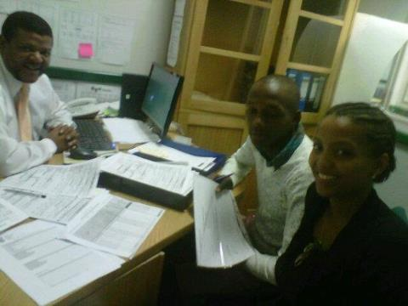
Thanks for your donation
Thanks to those who have supported us financially and otherwise this quarter. Without your support we would have struggled to implement our programmes for unemployed youth. A special thanks to:
- All our volunteers who have been working without salaries, some for almost a year now!
- All our partners who generously supported us such as Department of Labour, Jobstart, Dreamworker, University of the Western Cape, Adonai Life, Adriaanse and Bishop Lavis library, Economic Development Centre (Vredenburg), RLabs Social Media Academy, Cape Town Activa, Swartland Municipality, West Coast College and many more!
- Financial donations from Connie Van Dyk, Quinton Lesch in Cradock (originally from Bishop Lavis), Geoffrey Radcliff (New Zealand), Deidre (Ireland), Shamiela Naidoo (JHB but also from Bishop Lavis) and Soaya Allie (Saudi Arabia but from Ravensmead).
- Tygerburger newspaper for promoting our work.
- Radio 786, Radio CCFM and Cape Town TV for promoting us on air.
Shirley to join the board of directors
Shirley De Jongh who joined as a volunteer in September 2012 will be joining the YPW board of directors. She will be representing the staff on the board as well as be minute secretary. Welcome Shirley!
Rummy sale and Gospel Evening planned to raise funds
A rummy sale is planned for the end of June to raise funds. Thanks to the team of Dolly, Doreen and Valmare for organising this event! And thanks to all those who donated clothes and shoes such as Shirley De Jongh, Jayson Magooda, Marileze Johannes (our chairperson), Freda Camphor, Salma Ismail from UCT and many more! Earl Cornelius and his band will also be hosting a gospel evening at Adonia Life to raise funds for YPW on Saturday 13 July 2013. They will be supported by Jayson Magooda and friends, Shanique and Clothilda! Thank you guys for the support!
Matric Awareness Week – September 2013
As part of our focus to empower our youth, we will be targeting matriculants at high schools during a Matric Awareness Week at Bishop Lavis library in September. The focus will be to facilitate workshops in job seeking skills, personal development, money management and a day of sharing with our partners focusing on career advice and job/training opportunities beyond matric. A team was formed to coordinate this project.
Success stories!
Congratulations to the following volunteers who are now in fulltime or part-time employment:
- Charmonay Maasdorp working at Cape Town TV
- Aubrecia Kelly working at Debt Collectors in Durbanville
- Shaamilah Jassiem working at training company in Plattekloof
- Victoria Petersen working at Dreamworker
- Erica Laban doing part-time filing at the Wheat Women’s Trust
- Jessica Pietersen working as an intern at Foschini Head Office in Parow
Stephanie Jansen starts training at Jobstart
Oh yes, and Stephanie has been very busy after her job shadowing! She successfully enrolled for a 3 month course in hospitality at Jobstart in Greenpoint! It all started in February during our Youth Empowerment Week in Kraaifontein. There she shared her dream of running her own Bed and Breakfast service to Chance, the director of Jobstart. And the rest is history. She is now completing her course. Well done Stephanie! We are proud of you!
R50 donation from YPW members in employment
As part of our drive to become financially sustainable, it was decided that all volunteers who secure employment will be expected to make a R50 donation every month. This clause will be inserted into our volunteer application form. Those who have secured employment already will be requested to make a donation.
Our contact details: Frank Julie – Tel: 021 911 5444 or Cell: 078 812 4603; Shirley De Jongh – Tel: 021 695 5895 or Cell: 074 350 8582; Victoria – Cell: 073 721 0807
We Live to Work, We don’t Work to Live!!

